CSS BRITISH HISTORY · TOPIC 6 · KNOWLEDGE BASE
Victorian Britain and the World (1815–1907)
Britain’s foreign and imperial policy from Waterloo to the Triple Entente — Castlereagh, Canning, Palmerston, the Eastern Question, the Crimean War, Disraeli and Gladstone, the Empire, the Scramble for Africa and Splendid Isolation, with the legacy carried on to 2026

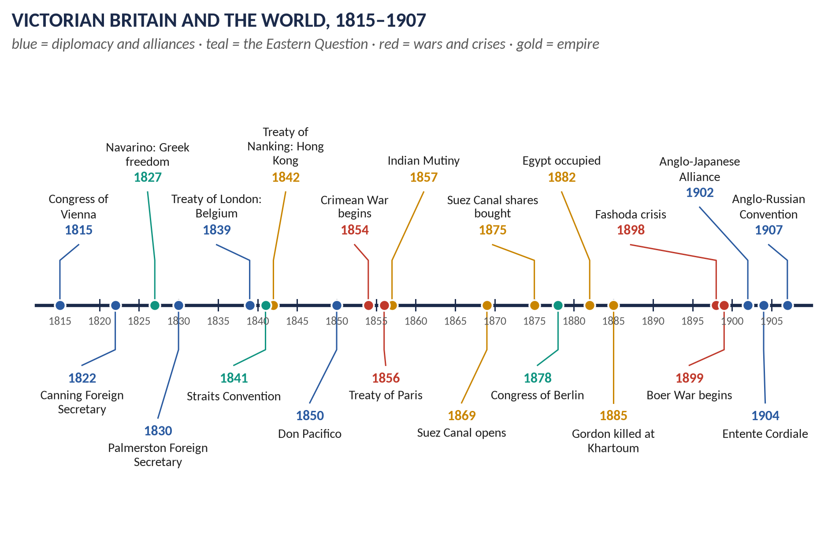
Syllabus heads IX and X (foreign affairs). 11 past items in 2015–2026 — Palmerston 3, Splendid Isolation 3, the Eastern Question, the Crimean War, the Treaty of Berlin, Disraeli and Gladstone 2 — and 4 MCQs. Told from zero, then nine chapters covering the whole head, not only what has been asked, with 120 one-liners and a stand-alone revision sheet.
Topic 6 of 10 · read with the companion document T6QA
Contents
HOW TO USE THIS · Updating the contents
Right-click the contents → Update Field → Update entire table, before saving as PDF.

How to Use This Document 6
What this Topic covers 6
Part Zero — The ABC Before the Story 7
0.1 What is "foreign policy"? 7
0.2 Britain's position in 1815 — the simple picture 7
0.3 Britain's five permanent interests 7
0.4 The map you need 8
0.5 The words you need 8
Part One — The Story 10
1.1 After Napoleon: keeping the peace (1815–1830) 10
1.2 The age of Palmerston (1830–1865) 10
1.3 The Crimean War (1853–1856) 10
1.4 Empire in Asia (1839–1880) 10
1.5 Disraeli, Gladstone and the Eastern crisis (1874–1885) 11
1.6 The Scramble for Africa (1881–1914) 11
1.7 Splendid Isolation — and its end (1870–1907) 11
Part Two — The Cast and the Time-line 12
2.1 The cast 12
2.2 The time-line 13
Part Three — The Chapters 14
Chapter 1 · The Foundations: Castlereagh, Canning and the Concert of Europe, 1815–1830 15
1.1 The Vienna Settlement (1814–15) 15
(i) What Britain wanted — and got 15
(ii) The alliances 15
1.2 Castlereagh and the Congress system (1815–1822) 15
1.3 Canning's foreign policy (1822–1827) 16
(i) Latin America 16
(ii) Portugal 16
(iii) Greece 16
1.4 Singapore and the East (1819) 17
Chapter 2 · Lord Palmerston 18
2.1 Who was Palmerston? 18
2.2 His principles 18
2.3 Palmerston as Foreign Secretary (1830–1841, 1846–1851) 19
(i) Belgium (1830–1839) — his first great success 19
(ii) Spain and Portugal — the Quadruple Alliance (1834) 19
(iii) The Near East — the Mehemet Ali crises (1831–1841) 19
(iv) China — the First Opium War (1839–1842) 20
(v) The Spanish Marriages (1846) — a failure 20
(vi) The 1848 revolutions 20
(vii) Don Pacifico (1850) — "Civis Romanus sum" 20
(viii) Dismissal (December 1851) 20
2.4 Palmerston as Prime Minister (1855–1858, 1859–1865) 20
(i) The Crimean War and the peace (1855–56) 20
(ii) The Second Opium War ("Arrow War", 1856–60) 21
(iii) The Indian Mutiny (1857–58) 21
(iv) The Orsini affair (1858) — fall 21
(v) Italian unification (1859–60) — success 21
(vi) The American Civil War (1861–65) 21
(vii) Poland (1863) and Denmark (1864) — humiliation 21
(viii) At home 21
2.5 Judging Palmerston 22
(i) "Radical and Jingo, but at heart neither Whig nor Tory" 22
(ii) "Conservative at home and liberal abroad" 22
(iii) More successful as Foreign Secretary than as Prime Minister? 22
Chapter 3 · The Eastern Question, 1820–1913 23
3.1 What was the Eastern Question? 23
(i) Why was Turkey declining? 23
(ii) What each power wanted 23
3.2 England's attitude, phase by phase 23
Phase 1 · 1820–1841: Greece and Mehemet Ali 23
Phase 2 · 1853–1856: the Crimean War 23
Phase 3 · 1856–1878: from Paris to Berlin 24
Phase 4 · 1878–1907: Egypt replaces Constantinople 24
Phase 5 · 1908–1913: the final crisis 24
Chapter 4 · The Crimean War, 1853–1856 26
4.1 The long-term background 26
4.2 The immediate causes (1852–1854) 26
4.3 The war 27
4.4 Mismanagement — and what it revealed 27
4.5 The Treaty of Paris (30 March 1856) 28
4.6 The results — analysed 28
(i) For the Eastern Question 28
(ii) For Europe 28
(iii) For Britain 28
(iv) For Russia 29
Chapter 5 · Disraeli, Gladstone and Foreign Affairs, 1868–1885 30
5.1 Two characters 30
5.2 Disraeli's foreign and imperial policy (1874–80) 31
(i) The programme — the Crystal Palace speech (June 1872) 31
(ii) The Suez Canal shares (November 1875) 31
(iii) The Royal Titles Act (1876) 31
(iv) The Eastern crisis (1875–78) 31
(v) San Stefano and Berlin (1878) 32
(vi) "Beaconsfieldism" — the forward policy 33
5.3 Gladstone's foreign policy 33
(i) His principles — the Midlothian speech (November 1879) 33
(ii) First ministry (1868–74) 33
(iii) Second ministry (1880–85) — principle meets reality 33
5.4 Comparing their policies 34
Chapter 6 · The Victorian Empire: India, China, the Great Game and Africa 35
6.1 India 35
6.2 China 35
6.3 The Great Game (c.1830–1907) 35
6.4 The Scramble for Africa (c.1881–1914) 36
(i) What it was 36
(ii) Causes 37
(iii) The Berlin Conference (1884–85) 37
(iv) Britain's share 37
(v) Fashoda (1898) 37
(vi) The Boer War (1899–1902) 37
6.5 The settler colonies 38
Chapter 7 · Splendid Isolation — and Its End, c.1870–1907 39
7.1 What "Splendid Isolation" meant 39
7.2 Why Britain adopted it 39
(i) Security 39
(ii) Interests 40
(iii) Politics and opinion 40
7.3 Why isolation became dangerous (1890–1902) 40
7.4 How isolation was abandoned 40
(i) Failed approaches to Germany (1898–1901) 40
(ii) Friendship with the USA 40
(iii) The Anglo-Japanese Alliance (30 January 1902) 41
(iv) The Entente Cordiale with France (8 April 1904) 41
(v) The Anglo-Russian Convention (31 August 1907) 41
7.5 Positive and negative aspects 41
7.6 Was it a right step or detrimental? — the arguments 42
Chapter 8 · The Legacy — to 2026 43
Part Four — Historians and Quotations 44
Part Five — The Examiner's Record 45
Part Six — The One-Liner Bank 46
One-liners · Foundations, 1815–1830 46
One-liners · Palmerston 46
One-liners · The Eastern Question and the Crimean War 47
One-liners · Disraeli, Gladstone and Berlin 48
One-liners · Empire 49
One-liners · Splendid Isolation and its end 50
Part Seven — Revision Sheet · Topic 6: Victorian Britain and the World 51
R6.1 Britain's five interests 51
R6.2 Castlereagh and Canning (1815–27) 51
R6.3 Palmerston 51
R6.4 The Eastern Question 52
R6.5 The Crimean War 52
R6.6 Disraeli, Gladstone and Berlin 52
R6.7 Empire 52
R6.8 Splendid Isolation and its end 53

How to Use This Document

What this Topic covers
Topic 6 is about Britain's dealings with other countries between 1815, when Napoleon was finally defeated, and 1907, when Britain joined France and Russia in the Triple Entente. It covers foreign policy (relations with the other Great Powers of Europe, America and Asia) and imperial policy (the growth of the British Empire in India, China and Africa). Topic 5 covered the same years at home; Topic 7 continues the foreign story into the First World War.
WHAT THE EXAMINER HAS ASKED · Why this topic matters
11 items in 2015–2026 plus 4 MCQs. Three favourite themes: Palmerston (2015 twice, 2016), the Eastern Question and the Crimean War (2015, 2016 short note, 2017), and Splendid Isolation (2015, 2018, 2023); plus Disraeli and Gladstone in foreign affairs (2015, 2016). The MCQs test the empire (Singapore, the Scramble for Africa, the Great Game) — so this Knowledge Base covers the whole head, including the parts never yet set as full questions.

THE STORY IN SIMPLE WORDS · Where this topic fits in the story
Topic 3 ended with Britain and its allies defeating Napoleon (Waterloo, 1815). For the next century Britain was the strongest power in the world — not because it had the biggest army (it did not), but because it had the biggest navy, the biggest trade, the richest economy and the largest empire. This topic explains how Britain used that power, and how, by 1907, the rise of Germany forced it to look for friends.

Part Zero — The ABC Before the Story

0.1 What is "foreign policy"?
A country's foreign policy is the set of aims and actions it follows in dealing with other countries: whom to befriend, whom to oppose, when to make treaties and when to fight. In Britain, foreign policy was run by the Foreign Secretary (the minister in charge of the Foreign Office), under the Prime Minister and the Cabinet.

0.2 Britain's position in 1815 — the simple picture
- An island: the sea protected Britain from invasion, so it did not need a huge army like France, Austria, Prussia or Russia.
- The Royal Navy: the largest and best navy in the world. It protected Britain, its trade and its colonies. The years 1815–1914 are sometimes called the Pax Britannica — the "British peace" kept by the navy.
- Trade and industry: Britain was the first industrial nation (Topic 4); it needed markets to sell to and safe sea routes.
- Empire: colonies in Canada, the Caribbean, the Cape of Good Hope, Australia — and, above all, India, "the jewel in the crown".

0.3 Britain's five permanent interests
Almost everything in this topic can be explained by five British interests. Learn them now; you will use them in every answer.
1. The balance of power: no single country should dominate Europe — because a master of Europe could threaten Britain (as Napoleon had).
2. Command of the sea: the navy must be stronger than any rival — later, stronger than any two rivals together.
3. Trade: open markets and free trade; protection of British merchants abroad.
4. The route to India: the sea and land routes to India — through the Mediterranean, Egypt and (after 1869) the Suez Canal, and across the Middle East — must never fall to a hostile power, above all Russia.
5. The Low Countries: Belgium and Holland, just across the Channel, must never be controlled by a Great Power — they were the natural base for an invasion of Britain.

0.4 The map you need
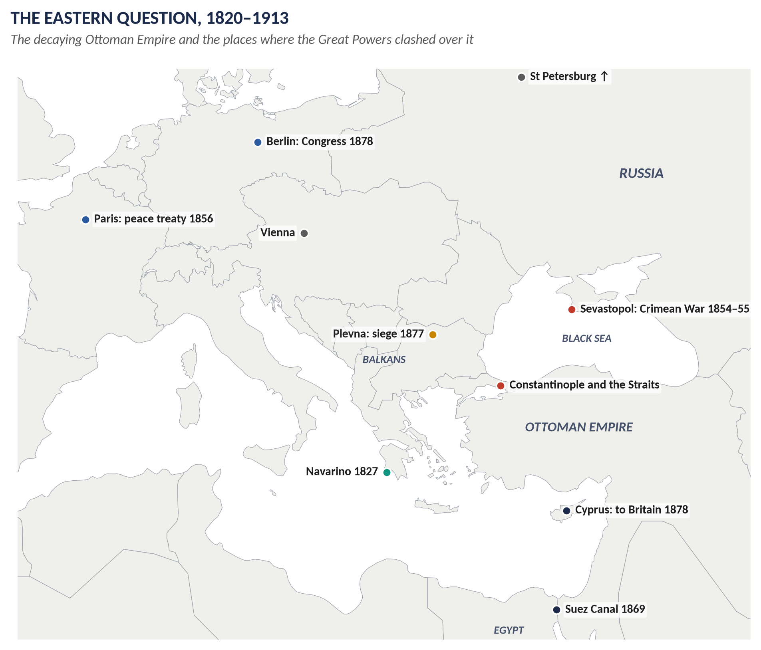
Figure 1 · Europe and the Near East: the stage of the Eastern Question.
- The Great Powers of Europe: Britain, France, Russia, Austria (Austria-Hungary from 1867) and Prussia (the German Empire from 1871). Italy became a sixth after 1861.
- The Ottoman Empire (Turkey): a huge but weakening Muslim empire ruled from Constantinople (Istanbul) by the Sultan. In 1815 it held the Balkans (south-east Europe: Greece, Serbia, Bulgaria, Romania, Bosnia), Asia Minor (modern Turkey), the Arab lands, and nominally Egypt.
- The Straits: the narrow waters — the Bosphorus and the Dardanelles — joining the Black Sea to the Mediterranean. Whoever controlled them could send warships between the two seas.

0.5 The words you need
Word | What it means, simply
Balance of power | An arrangement in which no one country is strong enough to dominate the others.
Great Powers | The strongest states of Europe: Britain, France, Russia, Austria, Prussia/Germany (later Italy).
Concert of Europe | The habit of the Great Powers meeting together in congresses and conferences to settle problems peacefully.
Congress system | Regular meetings of the powers after 1815 (1818–1822).
Intervention / non-intervention | Interfering / not interfering in another country's internal affairs.
Eastern Question | The problem of what should happen to the declining Ottoman Empire, and the rivalry of the powers over it.
Sick man of Europe | Nickname for the Ottoman Empire (Tsar Nicholas I, 1853).
Gunboat diplomacy | Using the threat of the navy to force weaker countries to do what you want.
Jingoism | Loud, aggressive patriotism — from a music-hall song of 1878: "We don't want to fight, but by Jingo if we do…"
Imperialism | The policy of gaining and ruling colonies and influence overseas.
Protectorate | A territory controlled by a stronger power, which runs its foreign affairs and defence.
Entente | French for "understanding": a friendly agreement, looser than an alliance.
Alliance | A treaty in which countries promise to help each other, usually in war.
Splendid Isolation | Britain's policy (c.1870–1902) of avoiding permanent peacetime alliances.
Arbitration | Settling a dispute by asking a neutral judge or panel to decide.

KEY IDEA · The one idea to hold on to
Britain's foreign policy changed its methods many times — congresses, gunboats, wars, isolation, ententes — but its interests hardly changed at all: the balance of power, command of the sea, trade, the route to India, and the safety of the Low Countries. As Palmerston said: "We have no eternal allies, and we have no perpetual enemies. Our interests are eternal and perpetual."

Part One — The Story
THE STORY IN SIMPLE WORDS · The story in simple words
Read this Part first, straight through. Every event is explained in detail in the chapters.

1.1 After Napoleon: keeping the peace (1815–1830)
In 1815 the victorious powers met at the Congress of Vienna and redrew the map of Europe. Britain's Foreign Secretary, Lord Castlereagh, wanted a balance of power and regular meetings to keep the peace. But the conservative monarchs of Russia, Austria and Prussia wanted to use the meetings to crush revolutions anywhere, and Britain refused to help. After Castlereagh's death (1822), George Canning openly broke away: Britain would not intervene to crush liberal movements. He recognised the new republics of Latin America, which had freed themselves from Spain, and helped the Greeks win independence from Turkey (the naval battle of Navarino, 1827).

1.2 The age of Palmerston (1830–1865)
For thirty-five years one man dominated British foreign policy: Lord Palmerston, Foreign Secretary for most of 1830–51 and Prime Minister for most of 1855–65. He helped create an independent Belgium (1839), defended liberal governments in Spain and Portugal, stopped France and Egypt from dominating Turkey (1840), and forced China to open its ports in the Opium War (1839–42), gaining Hong Kong. He loved to defend British subjects abroad with the threat of the navy — most famously for Don Pacifico in 1850. The British public adored him.

1.3 The Crimean War (1853–1856)
The Ottoman Empire was weak, and Russia wanted to control it — and the Straits. Britain feared that a Russian fleet in the Mediterranean would threaten its route to India. In 1854 Britain and France went to war to defend Turkey. The armies fought in the Crimea, a peninsula in the Black Sea, besieging the Russian naval base of Sevastopol. The war was badly managed — more British soldiers died of disease than in battle — but Florence Nightingale's nursing and the first war reporters made it famous. The Treaty of Paris (1856) banned Russian warships from the Black Sea.

1.4 Empire in Asia (1839–1880)
Britain expanded its power in Asia. In India, the great Mutiny (1857) was crushed, and in 1858 the Crown took over from the East India Company. In China, two Opium Wars opened the country to British trade. Across Central Asia, Britain and Russia played "the Great Game" — a long contest for influence over Afghanistan, Persia and Tibet, the lands between Russia's empire and British India.

1.5 Disraeli, Gladstone and the Eastern crisis (1874–1885)
The Conservative Benjamin Disraeli (PM 1874–80) wanted Britain to be proud, imperial and powerful. He bought shares in the new Suez Canal (1875), made Queen Victoria Empress of India (1876), and when Russia defeated Turkey and forced the harsh Treaty of San Stefano (1878), he threatened war. At the Congress of Berlin (1878) he forced Russia to give up most of its gains, and Britain took Cyprus. He came home claiming "Peace with Honour". The Liberal William Gladstone attacked him for supporting Turkey after the Turks massacred Bulgarians (1876) and for needless wars in Afghanistan and South Africa. Yet when Gladstone became Prime Minister (1880–85), he himself occupied Egypt (1882) and lost General Gordon at Khartoum (1885).

1.6 The Scramble for Africa (1881–1914)
In about twenty years the European powers divided almost the whole of Africa among themselves. Britain took Egypt, the Sudan, Nigeria, the Gold Coast, Kenya, Uganda, Rhodesia and more. Cecil Rhodes dreamed of British territory from the Cape to Cairo. Britain nearly went to war with France at Fashoda (1898), and fought the Boers of South Africa in the costly Boer War (1899–1902).

1.7 Splendid Isolation — and its end (1870–1907)
For most of the late nineteenth century Britain, under Lord Salisbury, avoided permanent alliances. It called this "Splendid Isolation": its navy made it safe, and it wanted its hands free. But in the 1890s Britain found itself quarrelling with the USA, France, Russia and a fast-rising Germany, which began building a great navy. During the Boer War all of Europe seemed hostile. Britain looked for friends: an alliance with Japan (1902), the Entente Cordiale with France (1904) and an agreement with Russia (1907). Isolation was over; the Triple Entente faced the Triple Alliance of Germany, Austria and Italy — the line-up of the First World War.
VERDICT · The story in one sentence
From 1815 to 1907 Britain used its navy, trade and diplomacy to keep a balance of power in Europe, to guard the route to India against Russia, and to build the largest empire in history — first through the Concert of Europe and Palmerston's bold diplomacy, then through Splendid Isolation, and finally, facing Germany, through friendships with Japan, France and Russia.

Part Two — The Cast and the Time-line

2.1 The cast
Person | Dates / office | Who they were — in one line
Lord Castlereagh | Foreign Sec. 1812–22 | Architect of the Vienna settlement; wanted a Concert, refused to crush revolutions.
George Canning | Foreign Sec. 1807–09, 1822–27; PM 1827 | Broke with the Congress system; recognised Latin America; helped Greece.
Lord Palmerston | Foreign Sec. 1830–41 (with a break), 1846–51; PM 1855–58, 1859–65 | "Pam": the most famous British foreign minister of the century.
Lord Aberdeen | Foreign Sec. 1828–30, 1841–46; PM 1852–55 | Peaceful diplomat; PM who drifted into the Crimean War.
Lord John Russell | PM 1846–52, 1865–66; Foreign Sec. 1859–65 | Whig leader; Palmerston's partner over Italy and the USA.
Tsar Nicholas I | Russia 1825–55 | Called Turkey "the sick man of Europe"; lost the Crimean War.
Napoleon III | France 1848–70 | Nephew of Napoleon; Britain's ally in the Crimea.
Florence Nightingale | 1820–1910 | Reformed army nursing at Scutari; "the Lady with the Lamp".
Benjamin Disraeli | PM 1868, 1874–80 | Earl of Beaconsfield; imperialist; "Peace with Honour" at Berlin.
William Gladstone | PM 1868–74, 1880–85, 1886, 1892–94 | Liberal moralist; attacked the "Bulgarian horrors" and "Beaconsfieldism".
Otto von Bismarck | German Chancellor 1871–90 | Unified Germany; "honest broker" at Berlin (1878).
Lord Salisbury | Foreign Sec. 1878–80; PM 1885–86, 1886–92, 1895–1902 | Master of "Splendid Isolation".
General Gordon | 1833–85 | Killed at Khartoum; a national hero.
Cecil Rhodes | 1853–1902 | Diamond magnate, Cape PM; dreamed of "Cape to Cairo".
Joseph Chamberlain | Colonial Sec. 1895–1903 | Imperialist; sought an alliance with Germany.
Lord Lansdowne | Foreign Sec. 1900–05 | Made the Japanese alliance (1902) and the Entente Cordiale (1904).
Sir Edward Grey | Foreign Sec. 1905–16 | Made the Anglo-Russian Convention (1907); "the lamps are going out" (1914).
King Edward VII | 1901–10 | His Paris visit (1903) prepared the Entente Cordiale.
Kaiser Wilhelm II | Germany 1888–1918 | Ambitious, erratic; the Kruger telegram; a great navy.

2.2 The time-line
Figure 2 · Victorian Britain and the World, 1815–1907.

Part Three — The Chapters

Chapter 1 · The Foundations: Castlereagh, Canning and the Concert of Europe, 1815–1830

1.1 The Vienna Settlement (1814–15)
After twenty years of war with France, the victors — Britain, Russia, Austria and Prussia — met at the Congress of Vienna to rebuild Europe. Their aims were to contain France, restore the old royal families, and create a balance of power so that no single country could dominate again.

(i) What Britain wanted — and got
- Containing France: strong states on France's borders — the Netherlands (Holland and Belgium united), Prussia on the Rhine, Piedmont-Sardinia in the south.
- Colonies and bases for the navy and trade: Malta, the Ionian Islands, Heligoland, the Cape of Good Hope, Ceylon, Mauritius, Trinidad.
- No land in Europe: Britain wanted security and trade, not territory — a very British choice.
- Condemnation of the slave trade by the powers.

(ii) The alliances
- The Quadruple Alliance (November 1815): Britain, Russia, Austria and Prussia promised to keep France in check and to meet regularly — the start of the Congress system.
- The Holy Alliance (September 1815): Tsar Alexander I's pledge that rulers would govern by Christian principles. Castlereagh called it "a piece of sublime mysticism and nonsense"; Britain did not join.

1.2 Castlereagh and the Congress system (1815–1822)
Congress | What happened
Aix-la-Chapelle (1818) | France admitted as a fifth power; allied troops left France. Castlereagh refused Russia's plan for a general guarantee of all thrones.
Troppau (1820) | Russia, Austria and Prussia issued the Troppau Protocol: the powers could intervene to crush revolutions. Britain sent only an observer.
Laibach (1821) | Austria authorised to crush the revolution in Naples.
Verona (1822) | France authorised to crush the liberal revolution in Spain (1823). Britain (Wellington, sent by Canning) refused and walked out — the end of the Congress system for Britain.

KEY IDEA · Castlereagh's State Paper of 5 May 1820
The key document of British policy. Castlereagh said the alliance was meant only to contain France and keep the 1815 settlement, "not … as a union for the government of the world, or for the superintendence of the internal affairs of other states". Britain would not join in putting down revolutions — the principle of non-intervention.

1.3 Canning's foreign policy (1822–1827)
George Canning, Foreign Secretary after Castlereagh's suicide in 1822, was a brilliant speaker who openly broke with the Congress powers and appealed to public opinion.

(i) Latin America
- Spain's colonies in South and Central America had rebelled and won independence. France and the Holy Alliance talked of helping Spain reconquer them.
- Canning warned France off (Polignac Memorandum, 1823); the USA issued the Monroe Doctrine (1823) against European intervention in the Americas.
- In 1824–25 Britain recognised the new republics (Argentina, Mexico, Colombia) — and gained huge markets for British trade.
- Canning boasted: "I called the New World into existence to redress the balance of the Old" (1826).

(ii) Portugal
When Spain threatened Portugal's constitutional government, Canning sent 4,000 troops to Lisbon (1826) — intervention to protect an old ally.

(iii) Greece
- The Greeks revolted against Turkish rule in 1821. British opinion was strongly pro-Greek (the poet Lord Byron died fighting for them, 1824).
- Canning worked with Russia (the St Petersburg Protocol, 1826) and then Russia and France (Treaty of London, 1827) to force a settlement — partly to stop Russia acting alone.
- At Navarino (20 October 1827) the British, French and Russian fleets destroyed the Turkish-Egyptian fleet. Greece became independent in 1830–32.
WHAT THE EXAMINER HAS ASKED · Castlereagh and Canning compared
Continuity: both defended British interests, the balance of power and non-intervention in others' domestic affairs. Difference: Castlereagh worked quietly inside the Concert; Canning broke out of it publicly and appealed to opinion and trade. Never yet set as a full question — a good candidate.

1.4 Singapore and the East (1819)
In 1819 Sir Stamford Raffles of the East India Company founded a trading post at Singapore, an island at the southern tip of the Malay Peninsula. Its value was its position on the Strait of Malacca — the main sea route between the Indian Ocean and China. It became a free port and one of the busiest harbours in the world; with Penang and Malacca it formed the Straits Settlements (1826).

Chapter 2 · Lord Palmerston
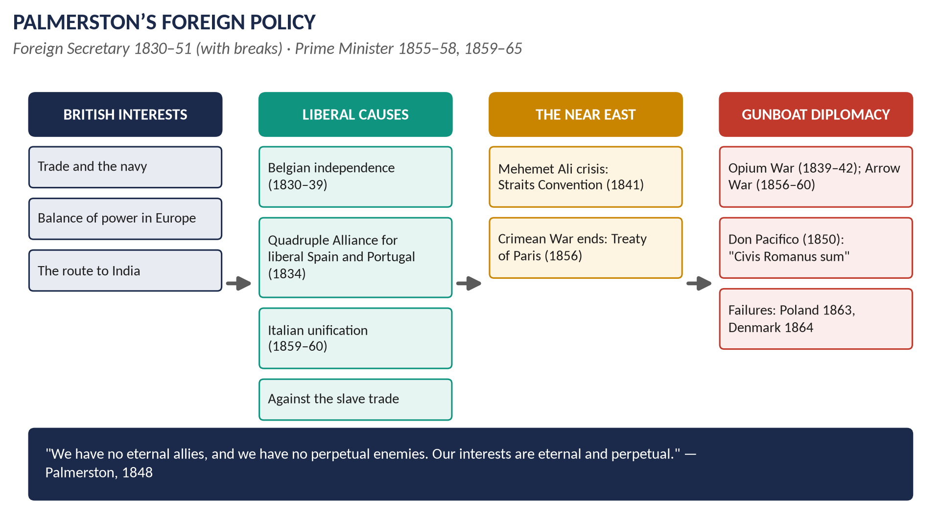
Figure 3 · Palmerston's foreign policy at a glance.

2.1 Who was Palmerston?
Henry John Temple, 3rd Viscount Palmerston (1784–1865). His title was Irish, so he could sit in the House of Commons — which he did for almost sixty years. He was known as "Pam" and, for his affairs with women, "Lord Cupid".
Years | Office and party
1809–28 | Secretary at War in Tory governments — almost twenty years in one post.
1828 | Left the Tory government with the Canningites (followers of Canning).
1830–34, 1835–41 | Foreign Secretary in the Whig governments of Grey and Melbourne.
1846–51 | Foreign Secretary again under Russell; dismissed in December 1851.
1852–55 | Home Secretary in Aberdeen's coalition.
1855–58 | Prime Minister (from February 1855, during the Crimean War).
1859–65 | Prime Minister again — the first head of the new Liberal Party; died in office, aged 80.

2.2 His principles
1. British interests first: "We have no eternal allies, and we have no perpetual enemies. Our interests are eternal and perpetual" (House of Commons, 1 March 1848).
2. The balance of power in Europe.
3. Constitutional, liberal government abroad — he believed parliamentary states like Britain's were more stable and friendlier to Britain. But he would not go to war for them unless British interests were at stake.
4. Protection of British subjects and trade everywhere — by the navy if necessary.
5. Abolition of the slave trade: he used the navy to hunt slave ships and pressed other countries to sign treaties.
6. Public opinion: he used the press and speeches to win popular support — the first foreign secretary to do so systematically.

2.3 Palmerston as Foreign Secretary (1830–1841, 1846–1851)

(i) Belgium (1830–1839) — his first great success
- In 1830 the Belgians revolted against the Dutch king. France might take Belgium — a threat to Britain's Channel coast.
- Palmerston worked through a London Conference of the powers: Belgium became an independent kingdom under Leopold of Saxe-Coburg (1831), and he used the threat of force to get the French army out and the Dutch to accept.
- Treaty of London (1839): the powers guaranteed Belgium's independence and neutrality — the "scrap of paper" for which Britain went to war in 1914.

(ii) Spain and Portugal — the Quadruple Alliance (1834)
Both countries had civil wars between liberal constitutional queens and absolutist uncles (Don Carlos in Spain, Dom Miguel in Portugal). Palmerston formed the Quadruple Alliance (1834) of Britain, France, Spain and Portugal to support the liberal side — a "liberal alliance of the West" against the conservative Eastern powers.

(iii) The Near East — the Mehemet Ali crises (1831–1841)
- Mehemet Ali, the powerful ruler of Egypt (nominally the Sultan's subject), attacked the Sultan in 1831–33 and conquered Syria.
- The desperate Sultan turned to Russia: the Treaty of Unkiar Skelessi (1833) made Turkey almost a Russian protectorate, with a secret clause closing the Straits to other powers' warships at Russia's request. Palmerston was alarmed.
- Second crisis (1839–41): Mehemet Ali, backed by France, again threatened the Sultan. Palmerston organised Britain, Russia, Austria and Prussia (Convention of London, 1840); the British navy bombarded Acre and forced Mehemet Ali back to Egypt (he kept Egypt as a hereditary ruler). France was isolated and backed down.
- The Straits Convention (1841): the powers agreed that the Straits would be closed to all foreign warships while Turkey was at peace — Unkiar Skelessi was cancelled.
- Result: Russia checked, France humbled, Turkey preserved — often called Palmerston's masterpiece.

(iv) China — the First Opium War (1839–1842)
- British merchants sold opium from India to China; the Chinese government banned it, and its commissioner Lin Zexu destroyed 20,000 chests of British opium at Canton (1839).
- Palmerston sent the navy. The Treaty of Nanking (1842, under Peel) gave Britain Hong Kong and opened five ports to trade.
- Critics (including the young Gladstone) called it an immoral war to protect drug-dealing.

(v) The Spanish Marriages (1846) — a failure
The French king Louis Philippe arranged for the Queen of Spain and her sister to marry in a way that might put a French prince's child on the Spanish throne. Palmerston was outwitted; the "entente" with France broke down.

(vi) The 1848 revolutions
- Palmerston sympathised with the liberal and national revolutions but did not intervene.
- He protected Hungarian refugees (Kossuth) in Turkey against Austrian and Russian demands (1849).
- He praised the London brewery workers who attacked the Austrian general Haynau — "the Hyena", who had flogged women in Hungary (1850) — to Queen Victoria's fury.

(vii) Don Pacifico (1850) — "Civis Romanus sum"
- David Pacifico, a Portuguese Jew born in Gibraltar (and so a British subject), had his house in Athens looted by a mob. The Greek government would not pay compensation.
- Palmerston sent the navy to blockade Greece and seize Greek ships until it paid.
- Attacked in Parliament, he made a famous five-hour speech (June 1850): as a Roman citizen once could say "Civis Romanus sum" ("I am a Roman citizen") and be safe anywhere, so a British subject "in whatever land he may be" should know that "the watchful eye and the strong arm of England" would protect him. The Commons backed him; he became a popular hero.

(viii) Dismissal (December 1851)
Palmerston approved Louis Napoleon's coup in France without consulting the Queen or the Cabinet. The Queen had long complained that he sent dispatches without showing them to her; Russell dismissed him. A few weeks later Palmerston brought down Russell's government ("my tit-for-tat with Johnny Russell").

2.4 Palmerston as Prime Minister (1855–1858, 1859–1865)

(i) The Crimean War and the peace (1855–56)
Palmerston became PM in February 1855 because the public wanted a vigorous war leader. Sevastopol fell (September 1855) and he secured the Treaty of Paris (1856) — Chapter 4.

(ii) The Second Opium War ("Arrow War", 1856–60)
The Chinese seized the Arrow, a ship flying (improperly) the British flag. Palmerston backed a bombardment of Canton. The Commons condemned him (Cobden's motion, 1857); he called an election and won a bigger majority. The war ended with the Convention of Peking (1860): Britain gained Kowloon.

(iii) The Indian Mutiny (1857–58)
Suppressed under his government; the Government of India Act (1858) ended East India Company rule — Chapter 6.

(iv) The Orsini affair (1858) — fall
An Italian, Orsini, tried to kill Napoleon III with bombs made in England. To please France, Palmerston introduced a Conspiracy to Murder Bill; the Commons saw it as bowing to a foreign despot and defeated him (February 1858).

(v) Italian unification (1859–60) — success
With Russell as Foreign Secretary, Palmerston's government gave moral and diplomatic support to Italian unity and discouraged others from intervening when Garibaldi invaded Naples (1860). Italy was united in 1861 — a friendly new state that balanced France and Austria.

(vi) The American Civil War (1861–65)
- Britain stayed neutral, though the upper classes sympathised with the South (the cotton trade) and working people with the North (against slavery).
- The Trent affair (1861): the US navy took two Confederate envoys from a British ship; war threatened until the North released them.
- The Alabama: a Confederate raider built in Birkenhead sank many Northern ships; the USA later won $15.5 million by arbitration (1872, Gladstone).

(vii) Poland (1863) and Denmark (1864) — humiliation
- When the Poles revolted against Russia (1863), Palmerston and Russell protested loudly but did nothing.
- In the Schleswig-Holstein crisis (1864), Palmerston told Parliament that Denmark would "not stand alone" if attacked. Bismarck's Prussia and Austria attacked Denmark; Britain, with no army to send and no ally, did nothing. Denmark lost the duchies. Lord Derby mocked the policy of "meddle and muddle". Palmerston's methods no longer worked against Bismarck.

(viii) At home
As PM he blocked further parliamentary reform ("there is really nothing to be done"); his government's main domestic achievements were Gladstone's budgets (1860) and the Divorce Act (1857). He won the 1865 election and died in October, aged 80 — and reform came two years later.

2.5 Judging Palmerston

(i) "Radical and Jingo, but at heart neither Whig nor Tory"
- Radical: he supported liberal and national movements abroad (Belgium, Spain, Portugal, Italy, Hungary's refugees) and the anti-slave-trade crusade; Radicals and the popular press cheered him.
- Jingo (the word came later, in 1878, but it fits): loud patriotism and gunboat diplomacy — Don Pacifico, the Opium Wars, the Arrow.
- Not a Whig: he did not share the Whigs' enthusiasm for domestic reform; after 1832 he opposed more.
- Not a Tory: he left the Tories in 1828, backed Catholic Emancipation and the Reform Act, and was liberal abroad.
- At heart: a Canningite and a patriot — his party was British interest and prestige.

(ii) "Conservative at home and liberal abroad"
Broadly true: he blocked reform at home and favoured constitutional governments abroad. But he was Home Secretary for useful reforms (Factory Act 1853, smoke abatement, the end of transportation to most colonies), and abroad his liberalism stopped wherever British interests stopped (Poland, Hungary, China).

(iii) More successful as Foreign Secretary than as Prime Minister?
 | Successes | Failures
Foreign Secretary | Belgium (1839); Quadruple Alliance (1834); Mehemet Ali and the Straits Convention (1840–41); Hong Kong (1842); popularity (1850) | Spanish Marriages (1846); bullying Greece; dismissal (1851)
Prime Minister | Won the Crimean War and the Paris peace; Mutiny suppressed; Italian unity; election victories 1857, 1859, 1865 | Fell over Orsini (1858); Poland (1863) and Denmark (1864) humiliations; no domestic programme

Most historians agree he was more successful as Foreign Secretary: then he shaped Europe; as Prime Minister he was a popular figurehead whose methods failed against Bismarck.
WHAT THE EXAMINER HAS ASKED · Where Chapter 2 has been asked
2015 P-I Q7 ("Radical and Jingo…") · 2015 P-II Q2 ("conservative at home and liberal abroad") · 2016 Q4 ("more successful as Foreign Minister than as Prime Minister").

Chapter 3 · The Eastern Question, 1820–1913

3.1 What was the Eastern Question?
The Eastern Question was the problem of what should happen to the declining Ottoman (Turkish) Empire — and of the rivalry between the Great Powers over its lands, above all the Balkans and the Straits.

(i) Why was Turkey declining?
- A backward economy and an army that lost to modern European forces.
- Corrupt, weak central government; provinces like Egypt almost independent.
- Christian peoples of the Balkans — Greeks, Serbs, Bulgarians, Romanians — who wanted independence, inspired by nationalism.

(ii) What each power wanted
Power | Aims
Russia | To control or open the Straits for its warships; to protect the Sultan's Orthodox Christians; to lead the Slav peoples of the Balkans; perhaps to take Constantinople.
Austria | To stop Russia gaining the Balkans; to keep Slav nationalism from spreading into its own empire.
France | Influence in the Near East, Egypt and Syria; protection of Catholics in the Holy Places.
Britain | To keep Russia away from the Straits and the Mediterranean; to protect the route to India; trade with Turkey; the balance of power. So, for most of the century, Britain propped up Turkey.
Germany (after 1871) | At first to keep the peace (Bismarck); later, under Wilhelm II, influence and railways in Turkey (the Berlin–Baghdad Railway).

3.2 England's attitude, phase by phase

Phase 1 · 1820–1841: Greece and Mehemet Ali
- Greek revolt (1821): Britain first stayed neutral, then (Canning) cooperated with Russia and France to control the outcome — Navarino (1827); Greek independence (1830–32).
- Mehemet Ali crises (1831–33, 1839–41): Palmerston propped up Turkey against Egypt and France, cancelled the Russian gains of Unkiar Skelessi (1833) and secured the Straits Convention (1841).
- Attitude: preserve Turkey; keep Russia and France out.

Phase 2 · 1853–1856: the Crimean War
Britain went to war to defend Turkey against Russia — Chapter 4. Attitude: preserve Turkey by force.

Phase 3 · 1856–1878: from Paris to Berlin
- 1870: during the Franco-Prussian War Russia repudiated the Black Sea clauses of 1856; the London Conference (1871) accepted it — Britain could do nothing.
- 1875–78: the great Eastern crisis — revolts in Bosnia and Bulgaria; the Bulgarian horrors; the Russo-Turkish War; San Stefano; the Congress of Berlin — Chapter 5. Disraeli supported Turkey; Gladstone and much of British opinion turned against the Turks.
- Attitude: still preserve Turkey, but now divided at home on moral grounds.

Phase 4 · 1878–1907: Egypt replaces Constantinople
- After buying the Suez Canal shares (1875) and occupying Egypt (1882), Britain could protect the route to India without relying on Turkey.
- The Armenian massacres (1894–96) destroyed British sympathy for the Sultan. Salisbury told the Lords in 1897 that in the Crimean War Britain had "put all its money on the wrong horse".
- Germany became Turkey's friend (Kaiser's visits 1889, 1898; Baghdad railway concession 1899–1903).
- The Anglo-Russian Convention (1907) settled rivalries in Persia, Afghanistan and Tibet — Britain and Russia became partners.
- Attitude: Turkey no longer essential; Egypt and the navy guard India.

Phase 5 · 1908–1913: the final crisis
- 1908: the Young Turk revolution; Austria annexed Bosnia (the Bosnian crisis), humiliating Russia and Serbia.
- 1911–12: Italy seized Libya from Turkey.
- The First Balkan War (1912): Serbia, Bulgaria, Greece and Montenegro drove Turkey almost out of Europe. Sir Edward Grey chaired the London Conference of Ambassadors (1912–13), which created Albania — the Treaty of London (May 1913).
- The Second Balkan War (1913): the victors fought over Macedonia; Bulgaria lost (Treaty of Bucharest, August 1913).
- Attitude: Britain acted as mediator, working with Germany to keep the peace — but the Balkans remained "the powder keg of Europe", and the assassination at Sarajevo in 1914 began the First World War (Topic 7).
Period | England's attitude, in one line
1820–41 | Preserve Turkey; control Greek independence; check Russia and France (Navarino, Straits Convention)
1853–56 | Fight Russia to preserve Turkey (Crimean War)
1856–78 | Preserve Turkey against Russia, but opinion divided (Berlin)
1878–1907 | Egypt and the Suez Canal replace Turkey; agreement with Russia (1907)
1908–13 | Mediator in the Balkan Wars (London Conference)

KEY IDEA · Critical analysis
Constant aim: keep Russia away from the Straits and the route to India. Changing method: support Turkey (1820–78) → rely on Egypt (1882) → reach agreement with Russia (1907). Weakness: Britain treated the Balkan peoples mainly as pieces in a great-power game, and propped up a corrupt, cruel empire for decades.

WHAT THE EXAMINER HAS ASKED · Where Chapter 3 has been asked
2017 Q6: explain the Eastern Question and England's attitude 1820–1913. Also 2015 P-II Q5 (Crimean War) and 2016 Q8(b) (Treaty of Berlin).

Chapter 4 · The Crimean War, 1853–1856
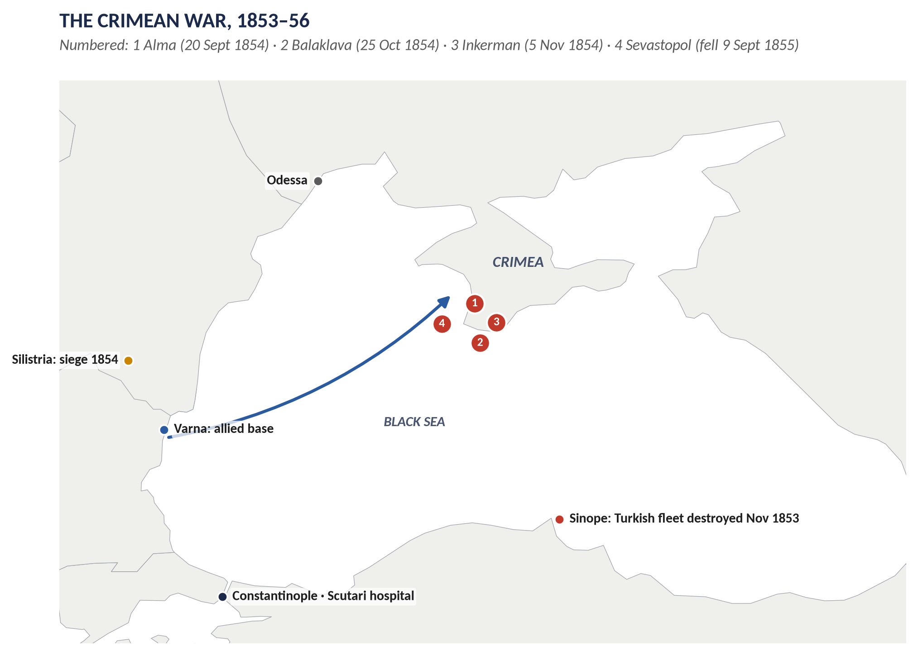
Figure 4 · The Crimean War: the Black Sea theatre.

4.1 The long-term background
- The Eastern Question: Tsar Nicholas I believed Turkey was dying — "a sick man" (1853) — and wanted to arrange its division with Britain in advance. Britain refused.
- Russian expansion: Russia wanted influence over the Sultan's Orthodox Christians (about a third of his subjects) and control of the Straits.
- British fears: a Russian fleet in the Mediterranean would threaten Malta, Egypt and the route to India; Russian power in Turkey would upset the balance of power. British public opinion was fiercely anti-Russian — Russia was seen as the oppressor of Poland and Hungary.
- France: Napoleon III wanted prestige and to break up the alliance of the conservative powers that had kept France down since 1815.

4.2 The immediate causes (1852–1854)
1. The Holy Places dispute: Catholic (French-backed) and Orthodox (Russian-backed) monks quarrelled over the keys to the churches in Bethlehem and Jerusalem. Under French pressure the Sultan favoured the Catholics (1852).
2. The Menshikov mission (1853): Nicholas sent Prince Menshikov to Constantinople to demand that Russia be recognised as protector of all Orthodox Christians in the empire — a right to interfere in Turkey's affairs. Advised by the British ambassador Stratford Canning, the Sultan refused.
3. The Principalities (July 1853): Russian troops occupied Moldavia and Wallachia (modern Romania). The British and French fleets moved to the Dardanelles.
4. The Vienna Note (1853): a compromise drafted by the powers failed — Turkey rejected it.
5. Turkey declared war (October 1853).
6. Sinope (30 November 1853): the Russian fleet destroyed a Turkish squadron in harbour — British newspapers called it a "massacre", and opinion demanded war.
7. The British and French fleets entered the Black Sea (January 1854); Britain and France declared war on Russia (28 March 1854).
WHY THIS ANSWER SCORES · Why did Aberdeen's peaceful government go to war?
Lord Aberdeen, the Prime Minister, hated war, but his cabinet was divided (Palmerston and Russell pressed for firmness), public opinion was inflamed, and each small step — moving the fleets — made retreat harder. Historians often describe Britain as having drifted into war.

4.3 The war
Date | Event
1854 | The Russians abandoned the Principalities after failing at Silistria; the allies decided to strike at Sevastopol, Russia's naval base in the Crimea.
20 Sept 1854 | Battle of the Alma: an allied victory.
25 Oct 1854 | Battle of Balaklava: the "thin red line" of Highlanders; the disastrous Charge of the Light Brigade — a misunderstood order sent 670 cavalry against Russian guns (Tennyson's poem).
5 Nov 1854 | Battle of Inkerman: "the soldiers' battle" in fog; a costly allied victory.
Winter 1854–55 | The army froze and starved on the heights before Sevastopol; cholera and dysentery killed thousands.
Jan–Feb 1855 | Roebuck's motion for an inquiry passed; Aberdeen resigned; Palmerston became PM. Sardinia (Piedmont) joined the allies.
March 1855 | Nicholas I died; Alexander II became Tsar.
9 Sept 1855 | Sevastopol fell after an eleven-month siege (the French took the Malakoff fort).
30 March 1856 | Treaty of Paris.

4.4 Mismanagement — and what it revealed
- Leadership: the commander Lord Raglan was 66 and had never commanded in the field; the cavalry commanders Lucan and Cardigan hated each other.
- Supply: soldiers without winter clothing, food rotting at Balaklava harbour, no proper roads (a railway was later built by civilian contractors).
- Disease: about 21,000 British soldiers died — about 16,000 of disease, not wounds.
- The press: William Howard Russell of The Times sent reports by the new electric telegraph — the first modern war correspondent. The public was horrified.
- Florence Nightingale: arrived at the military hospital at Scutari (near Constantinople) in November 1854 with 38 nurses; improved hygiene, food and care; "the Lady with the Lamp"; later founded modern nursing.
- Photography: Roger Fenton's war photographs (1855).

4.5 The Treaty of Paris (30 March 1856)
1. The Black Sea neutralised: no warships and no naval arsenals on its shores — for Russia or Turkey.
2. Russia gave up southern Bessarabia (at the mouth of the Danube) to Moldavia.
3. The Danube open to the ships of all nations, under an international commission.
4. Moldavia and Wallachia self-governing under Turkish rule, guaranteed by the powers (not by Russia alone).
5. Russia gave up its claim to protect the Sultan's Christians; the Sultan issued a decree of reforms and equal rights (Hatt-i Humayun, 1856).
6. Turkey admitted to the Concert of Europe; its independence and integrity guaranteed by the powers.
7. The Declaration of Paris: new rules of war at sea (privateering abolished).

4.6 The results — analysed

(i) For the Eastern Question
- Russia was checked — but only for about fifteen years: in 1870 it repudiated the Black Sea clauses, and the London Conference (1871) accepted this.
- Turkey was saved but not reformed; the promised reforms were not carried out.
- Romania: Moldavia and Wallachia united (1859–61) — a new Balkan nation.

(ii) For Europe
- The Concert of Europe was broken: Russia and Austria (which had not helped Russia) became enemies; Russia no longer defended the 1815 settlement. This made possible the unification of Italy (1859–61) and of Germany (1864–71).
- France under Napoleon III enjoyed a brief period of leadership in Europe.

(iii) For Britain
- Army reform: the scandal led in time to the Cardwell reforms (1868–74, Topic 5); the Victoria Cross was created (1856).
- Nursing and army medicine transformed.
- Aberdeen's fall and the rise of Palmerston (1855).
- Disillusion with continental war: Britain did not fight another European war until 1914 — part of the background to Splendid Isolation.
- Salisbury's verdict (1897): Britain had "put its money on the wrong horse".

(iv) For Russia
Defeat exposed Russia's backwardness; Alexander II began the Great Reforms, including the emancipation of the serfs (1861).
WHAT THE EXAMINER HAS ASKED · Where Chapter 4 has been asked
2015 P-II Q5: the background to the Crimean War and the results after the fighting ended. MCQ 2026: Britain fought the Crimean War against Russia.

Chapter 5 · Disraeli, Gladstone and Foreign Affairs, 1868–1885
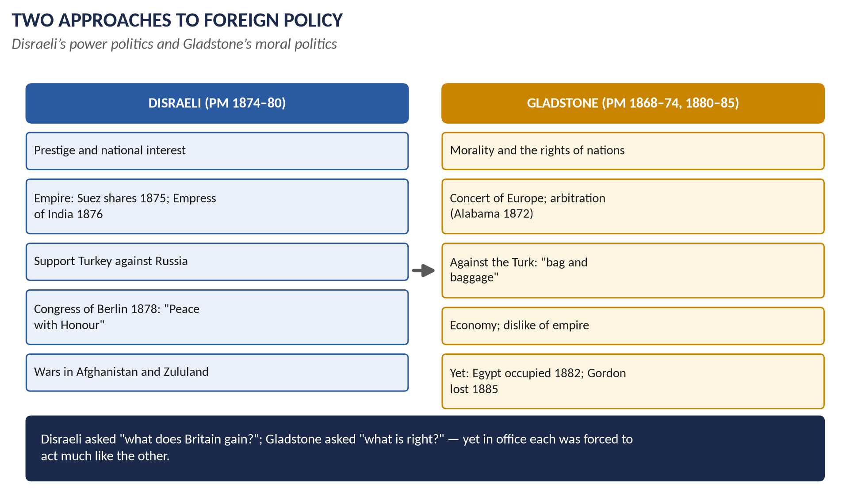
Figure 5 · Two approaches to foreign policy.

5.1 Two characters
 | Benjamin Disraeli (1804–81) | William Ewart Gladstone (1809–98)
Background | Born Jewish, baptised Anglican at 12; no university; a novelist (Coningsby, Sybil); a dandy with debts | Son of a rich Liverpool merchant; Eton and Oxford (double first)
Personality | Witty, romantic, theatrical, flattering; an opportunist who loved power and the game of politics | Earnest, devout (High Anglican), tireless, moralistic; saw politics as a Christian duty
The Queen | Her favourite — he flattered her; made her Empress of India; created Earl of Beaconsfield (1876) | She disliked him: "He speaks to me as if I were a public meeting"
Ideas | The nation, the empire, the Crown, the Church, "One Nation" | Liberty, morality, economy, the rights of peoples, the law of nations
Foreign policy | Prestige and power; British interests; imperial expansion | Principle; the Concert of Europe; arbitration; restraint

5.2 Disraeli's foreign and imperial policy (1874–80)

(i) The programme — the Crystal Palace speech (June 1872)
Disraeli said the Conservative Party stood for three things: to maintain the institutions of the country, to uphold the Empire, and to improve the condition of the people. He accused the Liberals of trying to break up the empire.

(ii) The Suez Canal shares (November 1875)
The Suez Canal (opened 1869, built by the French) had become Britain's main route to India. When the bankrupt Khedive (ruler) of Egypt offered his 44 per cent of the shares for sale, Disraeli bought them for £4 million, borrowed overnight from the Rothschild bank, without waiting for Parliament. "You have it, Madam," he told the Queen.

(iii) The Royal Titles Act (1876)
Queen Victoria became Empress of India — a symbol of the Crown's link with India and a warning to Russia.

(iv) The Eastern crisis (1875–78)
- 1875: Christian peasants revolted in Bosnia and Herzegovina.
- 1876: a rising in Bulgaria was crushed by Turkish irregular troops (bashi-bazouks) with massacres of about 12,000 (estimates vary widely) — "the Bulgarian horrors". Disraeli at first dismissed the reports as "coffee-house babble".
- Gladstone's pamphlet The Bulgarian Horrors and the Question of the East (September 1876) sold 200,000 copies: the Turks should leave Bulgaria "bag and baggage".
- Constantinople Conference (December 1876): the Sultan rejected the powers' reform plan.
- April 1877: Russia declared war on Turkey; after the long siege of Plevna (1877), Russian armies reached the outskirts of Constantinople (January 1878).
- Britain's response: the fleet sailed to Constantinople (February 1878); £6 million voted for war; Indian troops moved to Malta; London music halls sang "We don't want to fight, but by Jingo if we do, we've got the ships, we've got the men, we've got the money too" — hence jingoism.

(v) San Stefano and Berlin (1878)
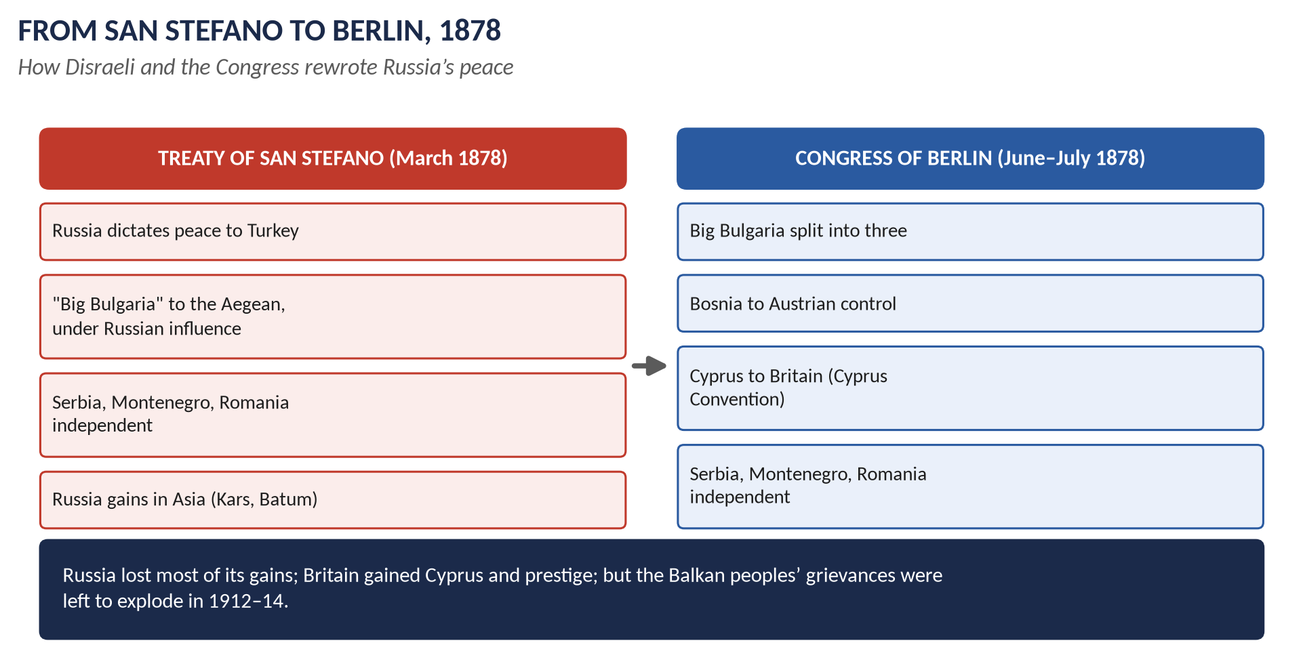
Figure 6 · From San Stefano to Berlin.
- The Treaty of San Stefano (3 March 1878), dictated by Russia to Turkey, created a huge "Big Bulgaria" reaching the Aegean Sea, which Britain and Austria saw as a Russian satellite giving Russia access to the Mediterranean.
- Lord Derby, the Foreign Secretary, resigned; Lord Salisbury replaced him and issued the Salisbury Circular (April 1878), demanding that the whole treaty be reviewed by the powers.
- Secret agreements: with Russia (to reduce Bulgaria), with Austria, and with Turkey — the Cyprus Convention (June 1878): Britain would occupy Cyprus and defend Turkey's Asian lands against Russia.
- The Congress of Berlin (13 June – 13 July 1878), chaired by Bismarck as "honest broker", produced the Treaty of Berlin:
  - Big Bulgaria split into three: a small self-governing Bulgaria (north), Eastern Rumelia (self-governing under Turkey), and Macedonia returned to Turkey.
  - Serbia, Montenegro and Romania fully independent.
  - Bosnia and Herzegovina occupied and administered by Austria-Hungary.
  - Russia kept southern Bessarabia and Kars and Batum in Asia.
  - Britain gained Cyprus.
- Bismarck said: "Der alte Jude, das ist der Mann" — "The old Jew, that is the man."
- Disraeli returned to cheering crowds: "I have returned from Berlin bringing peace — but a peace I hope with honour."
KEY IDEA · "Peace with Honour" — judged
For: war was avoided; Russia's gains were cut back; Britain gained Cyprus and prestige; the Concert of Europe worked. Against: the Balkan peoples' wishes were ignored (Bulgaria was reunited with Eastern Rumelia by 1885; Bosnia's occupation led to 1908 and 1914); Russia was humiliated and turned against Germany; Turkey was not reformed; and Disraeli's "forward" policy then produced costly wars in Afghanistan and Zululand.

(vi) "Beaconsfieldism" — the forward policy
- Afghanistan (1878–80): to stop Russian influence, the Viceroy Lytton invaded; the British envoy Cavagnari was murdered in Kabul (1879); the war was expensive and inconclusive.
- South Africa: the Transvaal was annexed (1877); the Zulu War (1879) began with the disaster of Isandlwana (22 January 1879), where about 1,300 British and African troops were killed.
- Gladstone's Midlothian campaign (1879–80) attacked "Beaconsfieldism" — the pursuit of prestige through needless wars — and the Liberals won the 1880 election.

5.3 Gladstone's foreign policy

(i) His principles — the Midlothian speech (November 1879)
1. Good government at home — to build national strength.
2. Preserve the blessings of peace.
3. Strive to cultivate and maintain the Concert of Europe.
4. Avoid needless and entangling engagements.
5. Acknowledge the equal rights of all nations.
6. Foreign policy should be inspired by the love of freedom.

(ii) First ministry (1868–74)
- Franco-Prussian War (1870): Britain stayed neutral but secured treaties with both sides guaranteeing Belgium.
- Black Sea (1870–71): Russia repudiated the 1856 clauses; Gladstone accepted it at the London Conference but insisted that treaties could be changed only by agreement of the powers.
- The Alabama arbitration (1872): a tribunal at Geneva awarded the USA $15.5 million for damage by the Confederate raider built in Britain; Gladstone paid — a landmark for arbitration, though many thought it weak.

(iii) Second ministry (1880–85) — principle meets reality
- South Africa: the Transvaal Boers revolted and defeated a British force at Majuba Hill (February 1881). Gladstone granted self-government under British "suzerainty" (Pretoria Convention, 1881; London Convention, 1884). Critics called it surrender.
- Egypt (1882): Egypt was bankrupt and controlled by British and French financial officials; a nationalist army revolt under Colonel Urabi (Arabi) threatened the canal and foreign lives. After riots in Alexandria, the British fleet bombarded the city (July 1882) and Sir Garnet Wolseley defeated Urabi at Tel-el-Kebir (September 1882). Britain occupied Egypt — "temporarily"; it stayed until 1956. Evelyn Baring (Lord Cromer) ran Egypt from 1883 to 1907.
- The Sudan (1884–85): the religious leader the Mahdi rose against Egyptian rule. Gladstone sent General Gordon to evacuate Khartoum; Gordon stayed; the relief expedition was sent late; Khartoum fell and Gordon was killed (26 January 1885). The public turned on the "G.O.M." ("Grand Old Man") — now "M.O.G.", "Murderer of Gordon".
- Penjdeh (1885): Russian forces clashed with Afghans on the frontier; Gladstone threatened war, and Russia accepted arbitration.

5.4 Comparing their policies
Issue | Disraeli | Gladstone
Aim | Prestige, power, empire | Justice, peace, law
Eastern Question | Support Turkey against Russia | Condemn Turkish cruelty; free the Balkan peoples
Method | Secret deals, threats, bold stroke (Suez) | Concert of Europe, arbitration, public argument
Empire | Expand and glorify it | Economise; avoid new burdens — but occupied Egypt
Wars | Afghanistan, Zululand | Egypt, Sudan (reluctantly)
Result | Berlin triumph; defeated 1880 | Moral influence; Majuba and Gordon damaged him

KEY IDEA · The paradox
In opposition each seemed the opposite of the other; in office both were driven by the same British interests — the route to India, the balance of power, trade. Disraeli bought the Suez shares; Gladstone occupied Egypt.

WHAT THE EXAMINER HAS ASKED · Where Chapter 5 has been asked
2015 P-II Q4 (characters and policies, with special reference to foreign affairs) · 2016 Q5 (Disraeli and "Peace with Honour") · 2016 Q8(b) (short note: the Treaty of Berlin).

Chapter 6 · The Victorian Empire: India, China, the Great Game and Africa

6.1 India
- The East India Company ruled much of India until 1858, under the supervision of the Board of Control in London.
- The Indian Mutiny (also called the War of Independence of 1857 or the Great Revolt), May 1857 – 1858:
  - Causes: annexations under Lord Dalhousie (the Doctrine of Lapse; Awadh/Oudh annexed 1856); fear of forced conversion; land and tax grievances; the greased cartridges of the new Enfield rifle, rumoured to be greased with cow and pig fat — offensive to Hindus and Muslims.
  - Events: sepoys rose at Meerut (10 May 1857) and marched to Delhi, proclaiming the Mughal emperor Bahadur Shah Zafar; sieges of Lucknow and Cawnpore (Kanpur); massacres and brutal reprisals on both sides; Delhi retaken (September 1857).
  - Results: the Government of India Act (1858): the Crown took over; a Secretary of State for India; the Governor-General became Viceroy; the Queen's Proclamation (1858) promised religious toleration; the army was reorganised; Bahadur Shah exiled to Burma.
- 1876: Victoria Empress of India (the Royal Titles Act).
- 1885: the Indian National Congress founded — the beginning of organised Indian nationalism.

6.2 China
- First Opium War (1839–42) → Treaty of Nanking: Hong Kong island; five treaty ports.
- Second Opium War (1856–60) → Treaties of Tientsin (1858) and the Convention of Peking (1860): Kowloon; more ports; legations in Peking; opium trade legalised. British and French troops burned the Summer Palace (1860).
- 1898: Britain leased the New Territories for 99 years — which is why Hong Kong returned to China in 1997.

6.3 The Great Game (c.1830–1907)
- What it was: a long rivalry between the British and Russian empires for influence over the lands between them — Afghanistan, Persia, Central Asia and Tibet. It was not one war but a century of exploration, spying, diplomacy and occasional war. The name was popularised by Rudyard Kipling's novel Kim (1901).
- Why: Russia advanced across Central Asia (Tashkent 1865, Samarkand 1868, Merv 1884); Britain feared a threat to India.
- Key episodes:
  - First Afghan War (1839–42): a British army was destroyed in the retreat from Kabul (January 1842).
  - Second Afghan War (1878–80) under Disraeli.
  - The Penjdeh incident (1885).
  - The Pamirs agreement (1895); Younghusband's expedition to Tibet (1903–04).
- End: the Anglo-Russian Convention (1907) — Chapter 7.

6.4 The Scramble for Africa (c.1881–1914)
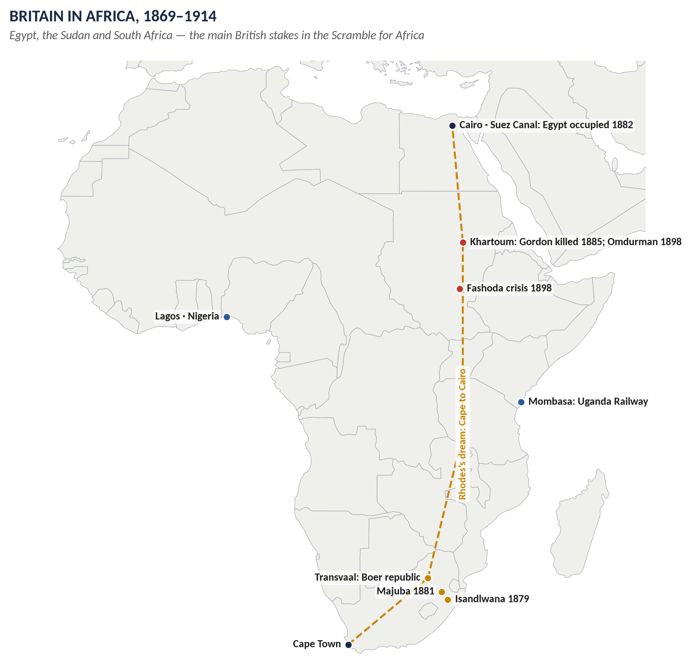
Figure 7 · Britain in Africa, 1869–1914.

(i) What it was
In 1870 Europeans controlled only about 10 per cent of Africa, mainly on the coasts. By 1914 they controlled about 90 per cent — only Ethiopia and Liberia stayed independent. This rapid division, roughly 1881–1914 (so spanning the 19th and 20th centuries), is called the Scramble for Africa.

(ii) Causes
1. Economic: raw materials (cotton, rubber, palm oil, gold, diamonds), markets and investment.
2. Strategic: protecting sea routes — for Britain, Egypt and the Suez Canal (route to India) and the Cape.
3. Rivalry and prestige: new powers (Germany, Italy) and France sought colonies as signs of greatness.
4. Technology: steamships, railways, the telegraph, quinine against malaria, the Maxim gun.
5. Ideas: missionaries, "civilising mission", Social Darwinism and racism.
6. The trigger: the British occupation of Egypt (1882), French moves on the Congo, and Bismarck's sudden colonies (1884).

(iii) The Berlin Conference (1884–85)
Chaired by Bismarck: rules for claiming African land ("effective occupation"); the Congo Free State for King Leopold II of Belgium; free trade on the Congo and Niger. No Africans were present.

(iv) Britain's share
- North and East: Egypt (occupied 1882); the Sudan (reconquered by Kitchener at Omdurman, 1898); British East Africa (Kenya) and Uganda (1890s), with the Uganda Railway from Mombasa.
- West: Nigeria (Royal Niger Company; colony 1900–1914), the Gold Coast (Ghana), Sierra Leone, Gambia.
- South and Centre: the Cape, Natal, Bechuanaland (1885), Rhodesia (Rhodes's British South Africa Company, 1889), Nyasaland; later the Transvaal and Orange Free State (1902).
- Cecil Rhodes' dream of a British strip from the Cape to Cairo.
- Agreements: the Heligoland–Zanzibar Treaty with Germany (1890).

(v) Fashoda (1898)
After Omdurman, Kitchener met a small French force under Captain Marchand at Fashoda on the Upper Nile (September 1898). War threatened; France backed down and recognised British control of the Nile valley (1899) — a step towards the Entente of 1904.

(vi) The Boer War (1899–1902)
- Background: the Boers (Afrikaners, of Dutch descent) ruled the Transvaal and Orange Free State; gold was found on the Witwatersrand (1886); British miners (Uitlanders) were denied the vote; the Jameson Raid (1895–96), backed by Rhodes, failed; the Kruger telegram (January 1896) from the Kaiser congratulated the Transvaal president.
- The war: Boer victories in "Black Week" (December 1899); sieges of Ladysmith, Kimberley and Mafeking (relieved 1900); British victories under Roberts and Kitchener; then two years of guerrilla war, met with farm-burning and concentration camps in which about 26,000 Boer women and children and many black Africans died.
- The Treaty of Vereeniging (May 1902): the Boer republics became British colonies, with a promise of self-government; the Union of South Africa followed in 1910.
- Cost: about 22,000 British dead; about £200 million; Britain condemned across Europe — a key reason for ending Splendid Isolation.

6.5 The settler colonies
- Canada: the Durham Report (1839) recommended responsible government; the Dominion of Canada (1867).
- Australia (Commonwealth, 1901) and New Zealand (Dominion, 1907) followed — the self-governing Dominions, ancestors of the Commonwealth (Topic 8).
WHAT THE EXAMINER HAS ASKED · Where Chapter 6 has been tested
Not yet as full questions; MCQs 2024: Singapore on the Strait of Malacca; the Scramble for Africa in the 19th and 20th centuries; the Great Game was a rivalry in Central Asia, not a war listed.

Chapter 7 · Splendid Isolation — and Its End, c.1870–1907
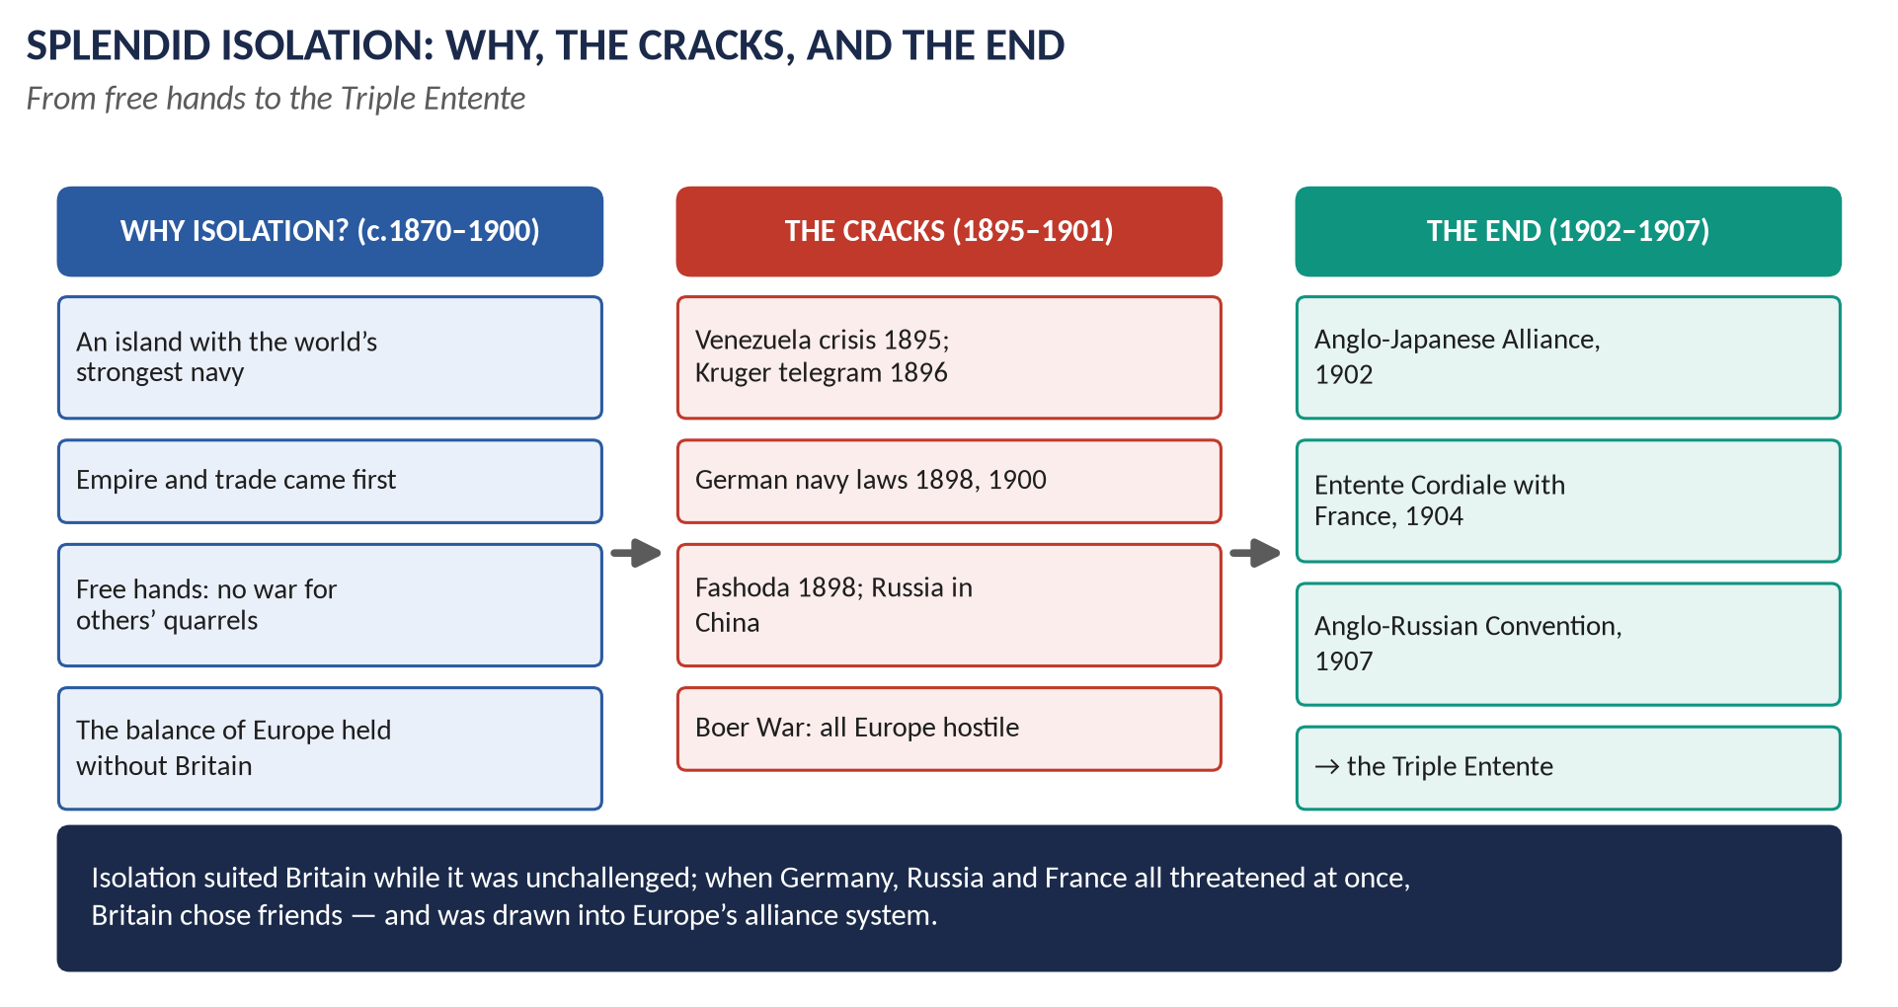
Figure 8 · Splendid Isolation: why, the cracks, and the end.

7.1 What "Splendid Isolation" meant
- The policy: Britain avoided permanent alliances with other Great Powers in peacetime. It kept its "free hands" — freedom to decide each issue as it arose, according to British interests.
- The phrase: first used in January 1896 by the Canadian politician George Foster, who said the "great Mother Empire stands splendidly isolated in Europe"; British ministers such as Goschen took it up. It became linked with Lord Salisbury, Prime Minister and usually also Foreign Secretary (1885–86, 1886–92, 1895–1902).
- Salisbury's own image: British policy was "to float lazily downstream, occasionally putting out a diplomatic boat-hook to avoid collisions".
- Dates: the attitude went back to Canning, but as a settled policy it is usually dated from about 1870 (after German unification) to 1902 (the Japanese alliance).
- Not total isolation: Britain signed limited agreements — the Mediterranean Agreements (1887) with Italy and Austria to keep the status quo in the Mediterranean and Near East; colonial deals with Germany (1890), France and Portugal.

7.2 Why Britain adopted it

(i) Security
- An island: the Channel and the Royal Navy protected Britain; it did not need allies to defend its soil.
- The navy: the Naval Defence Act (1889) set the Two-Power Standard — the navy must equal the next two largest navies combined.

(ii) Interests
- Empire and trade were global, not European; alliances could drag Britain into continental quarrels over lands it did not care about (Alsace-Lorraine, the Balkans).
- The balance of power held without Britain after 1871: Bismarck's Germany wanted peace, and his alliances (the Dual Alliance 1879, the Triple Alliance 1882, the Three Emperors' League, the Reinsurance Treaty 1887) kept Europe stable.

(iii) Politics and opinion
- Parliament and public opinion disliked secret, binding treaties; a British government could not promise that a future Parliament would go to war.
- The Crimean War had shown the costs of a continental war.
- Confidence: Britain was the richest, most industrial and most powerful state in the world.

7.3 Why isolation became dangerous (1890–1902)
1. Germany: after Bismarck's fall (1890), Wilhelm II pursued "Weltpolitik" (world policy); the Kruger telegram (1896); Tirpitz's Navy Laws (1898, 1900) began a fleet aimed at Britain.
2. France and Russia became allies (1894) — Britain's two traditional colonial rivals now combined.
3. Russia advanced in China (Port Arthur, 1898; Manchuria) and Central Asia.
4. France: rivalry in Africa — Fashoda (1898).
5. The USA: the Venezuela boundary crisis (1895) — President Cleveland threatened war.
6. The Boer War (1899–1902): all of Europe was hostile; the army's early failures showed how stretched Britain was.
7. Industrial decline, relatively: the USA and Germany had overtaken Britain in steel production.

7.4 How isolation was abandoned

(i) Failed approaches to Germany (1898–1901)
Joseph Chamberlain proposed an Anglo-German alliance (1898, 1899, 1901). Germany wanted Britain to join the Triple Alliance on German terms and believed Britain would never agree with France or Russia. The talks failed.

(ii) Friendship with the USA
The Hay–Pauncefote Treaty (1901) let the USA build and control a Panama canal; Britain withdrew most of its fleet from the Caribbean — the start of the Anglo-American friendship.

(iii) The Anglo-Japanese Alliance (30 January 1902)
- Made by: Lord Lansdowne (Foreign Secretary).
- Terms: if either power was at war with one power in the Far East, the other would stay neutral; if with two, the other would join in.
- Purpose: to check Russia in China and Korea, and to reduce the British fleet in the Far East.
- Significance: Britain's first peacetime alliance with a Great Power for decades — the formal end of Splendid Isolation. Japan defeated Russia in 1904–05; the alliance was renewed in 1905 and 1911 (lasted until 1923).

(iv) The Entente Cordiale with France (8 April 1904)
- Background: Fashoda had been settled; Edward VII's successful visit to Paris (May 1903); the French foreign minister Delcassé wanted friendship.
- Terms: France recognised British control of Egypt; Britain recognised French interests in Morocco; disputes over Newfoundland, Siam and the New Hebrides settled.
- Not an alliance — a settlement of colonial quarrels.
- Strengthened by Germany: the First Moroccan Crisis (1905–06) — the Kaiser's landing at Tangier — and the Algeciras Conference (1906), where Britain backed France; secret military conversations between the British and French general staffs began (1906).

(v) The Anglo-Russian Convention (31 August 1907)
- Made by: Sir Edward Grey (Liberal Foreign Secretary from 1905).
- Terms: Persia divided into a Russian zone (north), a British zone (south-east) and a neutral zone; Afghanistan recognised as a British sphere; Tibet neutral.
- Significance: the end of the Great Game; Britain, France and Russia now formed the Triple Entente, facing the Triple Alliance of Germany, Austria-Hungary and Italy.

7.5 Positive and negative aspects
Positive aspects of isolation | Negative aspects of isolation
Freedom of action: Britain could decide each issue on its merits | Friendless in crises: Venezuela, Kruger, Fashoda, the Boer War
No wars for others: Britain avoided every European war 1856–1914 | Could not restrain Germany's rise or its naval programme
Economy: money went to the navy rather than a huge army | Over-stretch: a global empire defended alone
Focus on empire and trade; the largest empire in history | Other powers could combine against Britain (France–Russia 1894)
Could bargain with all sides; Mediterranean Agreements when needed | Relative decline hidden until the Boer War exposed it

Positive aspects of ending it | Negative aspects of ending it
Security in the Far East (Japan) and the Mediterranean (France) | Britain drawn into the rival blocs of Europe
Colonial quarrels with France and Russia settled | Germany felt encircled and grew more aggressive
The navy could concentrate in the North Sea against Germany | Secret military talks created a moral obligation to France — part of the road to 1914

7.6 Was it a right step or detrimental? — the arguments
- Right in its time: from about 1870 to 1895 isolation cost Britain nothing and preserved peace and freedom.
- Detrimental by about 1895–1902: several rivals at once, and a Germany building a navy aimed at Britain, made isolation dangerous.
- Wisely abandoned: the ending was pragmatic — Britain settled its quarrels with the powers that threatened the empire (Japan against Russia, France, then Russia) — though it tied Britain to the Triple Entente.
WHAT THE EXAMINER HAS ASKED · Where Chapter 7 has been asked
2015 P-II Q7 (why adopted from 1870; how abandoned) · 2018 Q6 (how halted; positive and negative aspects) · 2023 Q4 (why initiated; your opinion — right step or detrimental?).

Chapter 8 · The Legacy — to 2026
Theme | What happened later
Belgium | The 1839 guarantee brought Britain into the First World War (August 1914).
The Straits and the Black Sea | The Montreux Convention (1936) still governs the Straits; in February 2022, after Russia's full-scale invasion of Ukraine, Turkey used it to close the Straits to warships of the warring states.
Crimea | Russia annexed Crimea in 2014; Sevastopol remains the base of Russia's Black Sea Fleet, which Ukrainian attacks forced to move much of its strength east from 2023–24 — the Crimean War's questions are live again.
Egypt and Suez | British occupation until 1956; the Suez Crisis (1956) ended Britain's great-power pretensions (Topic 9).
Hong Kong | Returned to China in 1997; after the National Security Law (2020) Britain opened a special visa route for Hong Kong residents (2021).
The Entente Cordiale | Its 120th anniversary was marked in 2024; the Lancaster House treaties (2010) made Britain and France close defence partners.
Japan | Echoes of 1902: the UK–Japan Hiroshima Accord and Reciprocal Access Agreement (2023), and the joint GCAP fighter programme with Italy.
Afghanistan | British and allied forces fought there again (2001–2021) — the "graveyard of empires".
Africa and the Commonwealth | Most British colonies won independence 1957–1980; the Commonwealth of 56 members; debates on reparations for slavery (Commonwealth summit, 2024).

Part Four — Historians and Quotations
Historian | The view to quote
A. J. P. Taylor, The Struggle for Mastery in Europe 1848–1918 (1954) | Diplomacy as a contest of power; Britain as an off-shore balancer.
Kenneth Bourne, The Foreign Policy of Victorian England (1970) | British policy was about interests, not principles.
Paul Kennedy, The Rise of the Anglo-German Antagonism (1980) | Economic and naval rivalry drove Britain from isolation to the Entente.
R. Robinson and J. Gallagher, Africa and the Victorians (1961); "The Imperialism of Free Trade" (1953) | Britain preferred informal empire (trade and influence) and took territory only when forced — often to protect the route to India.
C. H. D. Howard, Splendid Isolation (1967) | Isolation was a myth of convenience; Britain was never truly isolated.
Jasper Ridley, Lord Palmerston (1970); David Brown, Palmerston (2010) | Palmerston as the master of public opinion and the patriot above party.
Orlando Figes, Crimea (2010) | The Crimean War as a religious and imperial war with long consequences.
Robert Blake, Disraeli (1966) | Berlin as Disraeli's greatest triumph.

"I called the New World into existence to redress the balance of the Old." — Canning, 1826
"We have no eternal allies, and we have no perpetual enemies. Our interests are eternal and perpetual, and those interests it is our duty to follow." — Palmerston, 1848
"We have a sick man on our hands." — Tsar Nicholas I on Turkey, 1853
"I have returned from Berlin bringing peace — but a peace I hope with honour." — Disraeli, 1878
"We put all our money on the wrong horse." — Salisbury on the Crimean War, 1897

Part Five — The Examiner's Record
Paper | The question as set | Family | Type
2015 · Q7 · Paper I | 'Palmerston was at once a Radical and Jingo, but at heart neither a Whig nor a Tory.' Elucidate. | Palmerston | Quotation / claim
2015 · Q2 · Paper II | Palmerston was conservative at home and liberal abroad. Discuss and conclude with arguments. | Palmerston | Quotation / claim
2015 · Q4 · Paper II | Analyze the characters and policies of Gladstone and Disraeli with special reference to foreign affairs. | Gladstone vs Disraeli; Disraeli abroad | Compare / contrast
2015 · Q5 · Paper II | What was the background in the context of which the Crimean War broke out? Discuss and analyze the results that followed the cessation of hostilities. | The Eastern Question, Crimea, Berlin | Causes / results
2015 · Q7 · Paper II | Why did Britain adopt the Policy of Splendid Isolation from 1870 onwards in external affairs? How was this policy abandoned by the end of the 19th century? Discuss and analyze. | Splendid Isolation and its end | Causes / results
2016 · Q4 · Section A | 'Lord Palmerston was more successful as Foreign Minister than as Prime Minister.' Critically analyze. | Palmerston | Quotation / claim
2016 · Q5 · Section A | Explain the policy of Disraeli with special reference to 'Peace with Honour'. | Gladstone vs Disraeli; Disraeli abroad | Policy analysis
2016 · Q8(b) · Section B | Short note: Treaty of Berlin | The Eastern Question, Crimea, Berlin | Short note
2017 · Q6 · Section B | Explain the Eastern Question and critically analyse the attitude of England towards this question from 1820 to 1913. | The Eastern Question, Crimea, Berlin | Policy analysis
2018 · Q6 · Section B | How did Britain put a halt to the Policy of Splendid Isolation? What were its positive and negative aspects? | Splendid Isolation and its end | Causes / results
2023 · Q4 · Section A | Why did Britain initiate the Policy of Splendid Isolation? What is your personal opinion whether it was a right step in the right direction or proved detrimental? | Splendid Isolation and its end | How far / extent

WHAT THE EXAMINER HAS ASKED · The pattern
Palmerston is judged three ways: his politics (Radical and Jingo, 2015), the contrast of home and abroad (2015), and Foreign Secretary v Prime Minister (2016). Splendid Isolation is asked three ways: why and how abandoned (2015), how halted and its merits (2018), why and your opinion (2023). The Eastern Question comes as a whole (2017), as the Crimean War (2015) and as the Treaty of Berlin (2016). Disraeli and Gladstone in foreign affairs (2015, 2016). Never yet set as full questions: Castlereagh and Canning, the Scramble for Africa, the Boer War, India and the Mutiny, Egypt and the Sudan, the Great Game — the MCQs have begun to test them.

Part Six — The One-Liner Bank
HOW TO USE THIS · How to use the one-liners
Cover the answer after the arrow and say it aloud. 120 questions; bold words are the ones examiners test. The past MCQs are solved in T6QA.

One-liners · Foundations, 1815–1830
1. Which Congress redrew Europe in 1814–15? → The Congress of Vienna.
2. Who was Britain's Foreign Secretary at Vienna? → Lord Castlereagh.
3. What did Castlereagh call the Holy Alliance? → "A piece of sublime mysticism and nonsense".
4. Which 1815 alliance created the Congress system? → The Quadruple Alliance.
5. At which Congress was France readmitted (1818)? → Aix-la-Chapelle.
6. Which 1820 protocol claimed a right to crush revolutions? → The Troppau Protocol.
7. What did Castlereagh's State Paper of 5 May 1820 reject? → Intervention in other states' internal affairs.
8. At which Congress did Britain effectively walk out (1822)? → Verona.
9. Who succeeded Castlereagh as Foreign Secretary in 1822? → George Canning.
10. Which 1823 US declaration opposed European intervention in the Americas? → The Monroe Doctrine.
11. Who said "I called the New World into existence to redress the balance of the Old"? → Canning (1826).
12. Where did Canning send 4,000 troops in 1826? → Portugal.
13. Which naval battle of 1827 secured Greek independence? → Navarino.
14. Which English poet died helping the Greeks (1824)? → Lord Byron.
15. Who founded Singapore in 1819? → Sir Stamford Raffles.
16. On which sea route does Singapore stand? → The Strait of Malacca.

One-liners · Palmerston
17. What was Palmerston's nickname? → "Pam".
18. Why could Palmerston, a viscount, sit in the Commons? → His peerage was Irish.
19. Which post did he hold in Tory governments 1809–28? → Secretary at War.
20. With which group did he leave the Tories in 1828? → The Canningites.
21. When was Palmerston first Foreign Secretary? → 1830.
22. Complete: "We have no eternal allies…" → "…and we have no perpetual enemies. Our interests are eternal and perpetual."
23. Which 1839 treaty guaranteed Belgian neutrality? → The Treaty of London.
24. Who became King of the Belgians in 1831? → Leopold of Saxe-Coburg.
25. Which 1834 alliance supported liberal Spain and Portugal? → The Quadruple Alliance.
26. Which ruler of Egypt caused crises in 1831–33 and 1839–41? → Mehemet Ali.
27. Which 1833 treaty made Turkey almost a Russian protectorate? → Unkiar Skelessi.
28. Which 1841 agreement closed the Straits to foreign warships in peacetime? → The Straits Convention.
29. Which city did the British navy bombard in 1840? → Acre.
30. Which war (1839–42) gave Britain Hong Kong? → The First Opium War.
31. Which treaty ended it? → The Treaty of Nanking (1842).
32. Which Chinese commissioner destroyed British opium (1839)? → Lin Zexu.
33. Which 1846 marriages were a diplomatic defeat for Palmerston? → The Spanish Marriages.
34. Which Austrian general was attacked by London brewery workers (1850)? → General Haynau.
35. Who was Don Pacifico? → A Gibraltar-born British subject whose house in Athens was looted (1850).
36. What Latin phrase did Palmerston use in the Don Pacifico debate? → "Civis Romanus sum".
37. Why was Palmerston dismissed in December 1851? → He approved Louis Napoleon's coup without consulting the Queen or Cabinet.
38. When did Palmerston first become Prime Minister? → February 1855.
39. What was the Second Opium War also called? → The Arrow War (1856–60).
40. Which treaty of 1860 gave Britain Kowloon? → The Convention of Peking.
41. Which assassination plot brought Palmerston down in 1858? → The Orsini plot against Napoleon III.
42. Which 1861 incident nearly caused war with the USA? → The Trent affair.
43. Which Confederate raider was built in Birkenhead? → The Alabama.
44. Which 1864 crisis humiliated Palmerston? → Schleswig-Holstein (Denmark).
45. What did Lord Derby call Palmerston and Russell's policy? → "Meddle and muddle".
46. When did Palmerston die? → October 1865, in office, aged 80.

One-liners · The Eastern Question and the Crimean War
47. What was the Eastern Question? → The problem of the declining Ottoman Empire and the powers' rivalry over it.
48. Who called Turkey "the sick man of Europe"? → Tsar Nicholas I (1853).
49. What are the Straits? → The Bosphorus and Dardanelles, joining the Black Sea to the Mediterranean.
50. Which dispute over churches helped start the Crimean War? → The Holy Places dispute.
51. Which Russian envoy made demands in Constantinople in 1853? → Prince Menshikov.
52. Which provinces did Russia occupy in July 1853? → Moldavia and Wallachia.
53. Where was the Turkish fleet destroyed in November 1853? → Sinope.
54. When did Britain and France declare war on Russia? → 28 March 1854.
55. Against whom did Britain fight the Crimean War? → Russia.
56. Which Russian base was besieged? → Sevastopol.
57. Name the three battles of autumn 1854. → Alma, Balaklava, Inkerman.
58. What disaster happened at Balaklava? → The Charge of the Light Brigade.
59. Who was the British commander in the Crimea? → Lord Raglan.
60. Who was The Times's famous war reporter? → William Howard Russell.
61. Where did Florence Nightingale run her hospital? → Scutari.
62. Which PM resigned over the war in 1855? → Lord Aberdeen.
63. When did Sevastopol fall? → September 1855.
64. Which treaty ended the war? → The Treaty of Paris, 30 March 1856.
65. What did it do to the Black Sea? → Neutralised it — no warships.
66. When did Russia repudiate the Black Sea clauses? → 1870 (accepted at London, 1871).
67. Which medal was created in 1856? → The Victoria Cross.
68. What did Salisbury say of Britain's Crimean policy (1897)? → Britain "put its money on the wrong horse".

One-liners · Disraeli, Gladstone and Berlin
69. What title did Disraeli take in 1876? → Earl of Beaconsfield.
70. What three aims did Disraeli set out at the Crystal Palace (1872)? → Institutions, the Empire, the condition of the people.
71. When did Disraeli buy the Suez Canal shares? → November 1875.
72. For how much? → £4 million (from the Rothschilds).
73. What share of the canal did Britain buy? → About 44 per cent.
74. Which Act made Victoria Empress of India? → The Royal Titles Act (1876).
75. What were the "Bulgarian horrors"? → Turkish massacres of Bulgarians in 1876.
76. Which pamphlet did Gladstone write in 1876? → The Bulgarian Horrors and the Question of the East.
77. What did Gladstone say the Turks should do? → Leave "bag and baggage".
78. When did Russia declare war on Turkey? → April 1877.
79. Which long siege of 1877 delayed the Russians? → Plevna.
80. Where does the word jingoism come from? → A music-hall song of 1878 ("by Jingo").
81. Which treaty created "Big Bulgaria"? → San Stefano (3 March 1878).
82. Who replaced Derby as Foreign Secretary in 1878? → Lord Salisbury.
83. Which island did Britain gain in 1878? → Cyprus (Cyprus Convention).
84. Who chaired the Congress of Berlin as "honest broker"? → Bismarck.
85. What happened to Big Bulgaria at Berlin? → Split into three (Bulgaria, Eastern Rumelia, Macedonia).
86. Which provinces went to Austrian administration? → Bosnia and Herzegovina.
87. What did Disraeli claim to bring back from Berlin? → "Peace with Honour".
88. Where was the British army defeated by the Zulus (1879)? → Isandlwana.
89. What did Gladstone call Disraeli's forward policy? → "Beaconsfieldism".
90. How much did the Alabama arbitration (1872) award the USA? → $15.5 million.
91. Where did the Boers defeat the British in 1881? → Majuba Hill.
92. Which battle of 1882 gave Britain control of Egypt? → Tel-el-Kebir.
93. Who ran Egypt for Britain from 1883? → Evelyn Baring, Lord Cromer.
94. When was General Gordon killed at Khartoum? → 26 January 1885.
95. What did Gordon's death turn "G.O.M." into? → "M.O.G." — Murderer of Gordon.

One-liners · Empire
96. Where did the Indian Mutiny begin (10 May 1857)? → Meerut.
97. What rumour about cartridges helped cause it? → They were greased with cow and pig fat.
98. Which Act of 1858 ended Company rule in India? → The Government of India Act.
99. What was the Great Game? → The Anglo-Russian rivalry in Central Asia (Afghanistan, Persia, Tibet).
100. Which novel popularised the phrase? → Kipling's Kim (1901).
101. When did the Scramble for Africa take place? → About 1881–1914 — the 19th and 20th centuries.
102. Which conference of 1884–85 set rules for the Scramble? → The Berlin Conference.
103. Whose dream was "Cape to Cairo"? → Cecil Rhodes.
104. Where did Kitchener defeat the Mahdists in 1898? → Omdurman.
105. Where did British and French forces meet in 1898? → Fashoda.
106. Which raid of 1895–96 helped cause the Boer War? → The Jameson Raid.
107. Which treaty ended the Boer War? → Vereeniging (1902).
108. Which report of 1839 recommended responsible government in Canada? → The Durham Report.
109. When did Canada become a Dominion? → 1867.

One-liners · Splendid Isolation and its end
110. What was Splendid Isolation? → Avoiding permanent peacetime alliances, c.1870–1902.
111. Which PM is most linked with it? → Lord Salisbury.
112. What was the Two-Power Standard (1889)? → The navy must equal the next two navies combined.
113. Which 1887 agreements were a limited exception? → The Mediterranean Agreements.
114. What message did the Kaiser send in January 1896? → The Kruger telegram.
115. Who tried to make an alliance with Germany (1898–1901)? → Joseph Chamberlain.
116. When was the Anglo-Japanese Alliance signed? → 30 January 1902.
117. Which Foreign Secretary made it? → Lord Lansdowne.
118. When was the Entente Cordiale signed? → 8 April 1904.
119. What did it trade? → Egypt (for Britain) for Morocco (for France).
120. What did the Anglo-Russian Convention (1907) divide? → Persia (and settled Afghanistan and Tibet).

Part Seven — Revision Sheet · Topic 6: Victorian Britain and the World
HOW TO USE THIS · How to use this sheet
Complete on its own for the night before the paper. Syllabus Heads IX–X (foreign affairs). Asked: Palmerston (2015 ×2, 2016), Eastern Question (2017), Crimean War (2015), Treaty of Berlin (2016 sn), Disraeli and Gladstone (2015, 2016), Splendid Isolation (2015, 2018, 2023).

R6.1 Britain's five interests
1. Balance of power in Europe. 2. Command of the sea. 3. Trade. 4. The route to India (Mediterranean, Egypt, Suez; keep Russia from the Straits). 5. The Low Countries (Belgium) free of any Great Power. Palmerston: "no eternal allies… our interests are eternal."

R6.2 Castlereagh and Canning (1815–27)
Vienna 1815: balance of power; bases (Malta, Cape, Ceylon); Quadruple Alliance; Holy Alliance "sublime mysticism and nonsense". Congresses: Aix 1818, Troppau 1820 (Protocol), Laibach 1821, Verona 1822 (Britain out). State Paper 5 May 1820: no intervention in internal affairs. Canning: Latin America recognised 1824–25 ("called the New World into existence", 1826); Portugal 1826; Greece — Treaty of London 1827, Navarino 1827. Singapore 1819 (Raffles, Strait of Malacca).

R6.3 Palmerston
- Career: Tory Secretary at War 1809–28; Canningite; Foreign Sec. 1830–41, 1846–51; Home Sec. 1852–55; PM 1855–58, 1859–65; died 1865.
- As FM: Belgium (London 1839); Quadruple Alliance 1834; Mehemet Ali — Unkiar Skelessi 1833 reversed, Acre 1840, Straits Convention 1841; Opium War, Nanking 1842 (Hong Kong); Spanish Marriages 1846 (failure); 1848 — sympathy not intervention; Haynau; Don Pacifico 1850 ("Civis Romanus sum"); dismissed Dec 1851.
- As PM: Crimean victory, Paris 1856; Arrow War, Peking 1860; Mutiny, 1858 Act; Orsini — fell 1858; Italy 1859–60; American Civil War (Trent, Alabama); Poland 1863, Denmark 1864 humiliations ("meddle and muddle"); blocked reform.
- Judgements: Radical and Jingo — liberal causes + gunboats; neither Whig nor Tory — a Canningite patriot. Conservative at home, liberal abroad — broadly true; liberal only where British interests allowed. More successful as FM than PM — yes: shaped Europe as FM; as PM outplayed by Bismarck, no home programme.

R6.4 The Eastern Question
- Definition: what to do with the declining Ottoman Empire; rivalry of the powers — Russia (Straits, Orthodox, Slavs), Austria (Balkans), France (Holy Places, Egypt), Britain (route to India; stop Russia).
- England's attitude: 1820–41 preserve Turkey; Navarino; Straits Convention · 1853–56 fight Russia (Crimea) · 1856–78 preserve Turkey; Berlin; opinion split (Bulgarian horrors) · 1878–1907 Egypt replaces Turkey (1882); Armenian massacres; "wrong horse"; agreement with Russia 1907 · 1908–13 Young Turks; Bosnian crisis; Balkan Wars; Grey's London Conference, Treaty of London 1913. Constant aim, changing method.

R6.5 The Crimean War
- Background: "sick man"; Russian aims; British fears for India route; Napoleon III's prestige; Holy Places; Menshikov 1853; Principalities occupied; Vienna Note fails; Sinope (30 Nov 1853); war 28 March 1854; Aberdeen "drifted".
- War: Alma (20 Sept), Balaklava (25 Oct — Light Brigade), Inkerman (5 Nov 1854); winter; Sevastopol fell Sept 1855. Raglan; Russell of The Times; Nightingale at Scutari; ~21,000 British dead (~16,000 disease); Aberdeen out, Palmerston in.
- Treaty of Paris (30 March 1856): Black Sea neutralised; southern Bessarabia lost; Danube free; Principalities guaranteed; Turkey in the Concert.
- Results: Russia checked till 1870–71; Concert broken → Italy and Germany unify; Romania 1859–61; army reform, VC, nursing; Russian serfs freed 1861; "wrong horse".

R6.6 Disraeli, Gladstone and Berlin
- Characters: Disraeli — romantic, witty, opportunist, imperialist, the Queen's favourite. Gladstone — devout, earnest, moralist, economist; the Queen disliked him.
- Disraeli: Crystal Palace 1872; Suez shares Nov 1875 (£4m, 44%); Empress of India 1876; Bulgarian horrors ("coffee-house babble"); Russo-Turkish war 1877; fleet to Constantinople; jingo song; San Stefano (3 March 1878, Big Bulgaria); Salisbury Circular; Cyprus Convention; Berlin (June–July 1878): Bulgaria cut into 3; Serbia, Montenegro, Romania independent; Bosnia to Austria; Cyprus to Britain — "Peace with Honour"; then Afghan War, Isandlwana 1879.
- Gladstone: six Midlothian principles (peace, Concert, no entanglements, equal rights of nations, love of freedom); Alabama 1872; Black Sea 1871; Majuba 1881; Egypt 1882 (Tel-el-Kebir); Gordon killed 1885; Penjdeh 1885.
- Verdict: prestige v principle — but in office both served the same interests.

R6.7 Empire
India: Mutiny 1857 (Meerut; greased cartridges; Delhi, Lucknow, Cawnpore) → Government of India Act 1858; Empress 1876; Congress 1885. China: Nanking 1842, Peking 1860, New Territories lease 1898 (returned 1997). Great Game: Anglo-Russian rivalry in Central Asia; Afghan wars 1839–42, 1878–80; Penjdeh 1885; ended 1907. Scramble for Africa (~1881–1914): causes (economic, strategic, rivalry, technology, ideas); Berlin Conference 1884–85; Egypt, Sudan (Omdurman 1898), Nigeria, Gold Coast, Kenya, Uganda, Rhodesia; Fashoda 1898; Boer War 1899–1902 (Jameson Raid, Kruger telegram, concentration camps, Vereeniging).

R6.8 Splendid Isolation and its end
- Meaning: no permanent peacetime alliances; free hands; Salisbury ("float lazily downstream"); phrase 1896 (Foster).
- Why: island + navy (Two-Power Standard 1889); empire and trade; balance held by Bismarck; Parliament disliked binding treaties; Crimean lesson; confidence. Exception: Mediterranean Agreements 1887.
- Dangers 1890–1902: Weltpolitik; Kruger telegram 1896; Navy Laws 1898, 1900; Franco-Russian alliance 1894; Russia in China; Fashoda 1898; Venezuela 1895; Boer War isolation.
- How ended: Chamberlain's German approaches fail (1898–1901); Hay–Pauncefote 1901; Anglo-Japanese Alliance 30 Jan 1902 (Lansdowne); Entente Cordiale 8 April 1904 (Egypt/Morocco; Edward VII; tested at Algeciras 1906); Anglo-Russian Convention 31 Aug 1907 (Grey; Persia, Afghanistan, Tibet) → Triple Entente.
- Positive: freedom, no wars, economy, focus on empire. Negative: friendless in crises, couldn't restrain Germany, over-stretch. Opinion: right until c.1895; detrimental after; wisely ended — but led into the blocs of 1914.
VERDICT · The whole topic in one sentence
Britain's methods changed — congresses, Palmerston's gunboats, the Crimean War, Disraeli's bold strokes, Gladstone's Concert, Salisbury's isolation, Lansdowne's and Grey's ententes — but its interests never did: the balance of power, the sea, trade and, above all, the route to India.

